**Project 3: static-website-aws-s3-route53-cloudfront-acm-https.**

**Objective:**

Create and configure a simple static website. It will through configuring that static website with a custom error page. To demonstrate how to create a cost-efficient website hosting for sites that consist of files like HTML, CSS, JavaScript, fonts, and images.

**Tasks:**

1. Create Amazon S3 bucket
2. Redirect non-www URL to www URL via s3 bucket
3. Create SSL certificate using ACM service
4. Create Cloudfront distribution
5. Link Cloudfront distribution to Route53
6. Invalidate Cloudfront cache to update the latest changes in website

Cost:

1. The first 1,000 invalidation paths that you submit per month are free
2. you pay for each invalidation path over 1,000 in a month.
3. An invalidation path can be for a single file (such as /images/logo.jpg) or for multiple files (such as /images/\*).
4. A path that includes the \* wildcard counts as one path even if it causes CloudFront to invalidate thousands of files

**Services Used:**

Amazon S3

Route53 - Custom domain (prafulcloud.com)

Cloudfront

Certiificate Manager

**Diagram:**

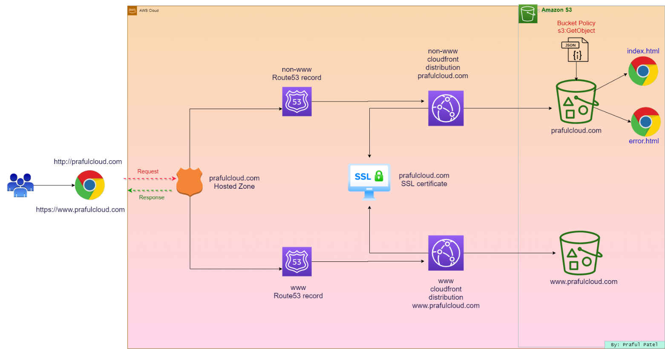

Log in to the AWS console.

Search for Route53

Click on Route53

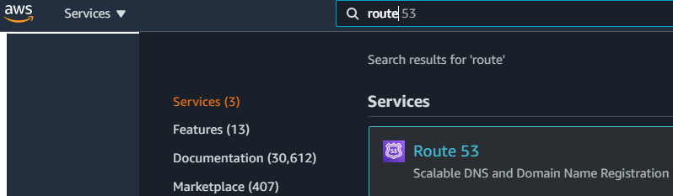

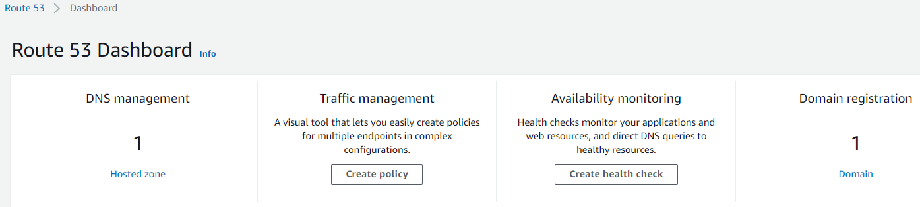

Click to Hosted Zone

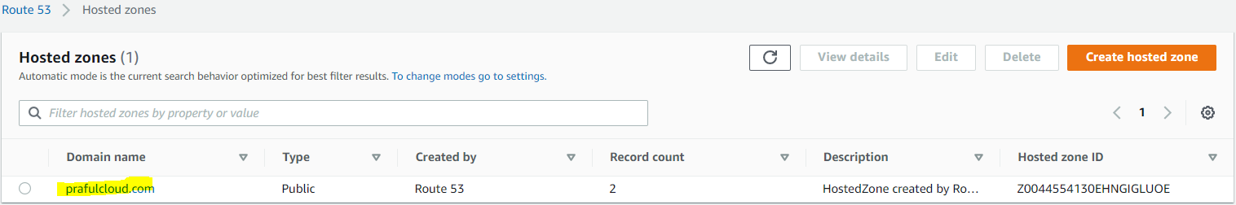

Create a S3 Data bucket with the same name as hosted zone

S3 is a global service.

Go to S3 service

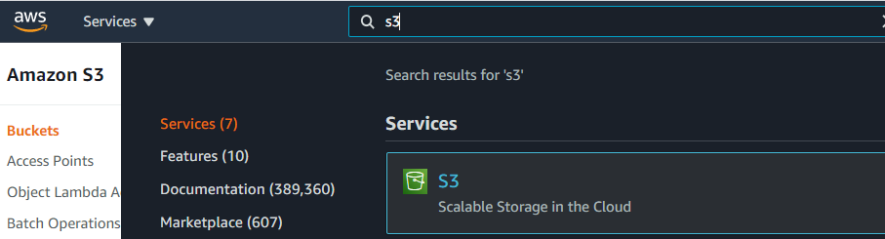

Create S3 Bucket

Navigate to S3.

Click Create bucket.

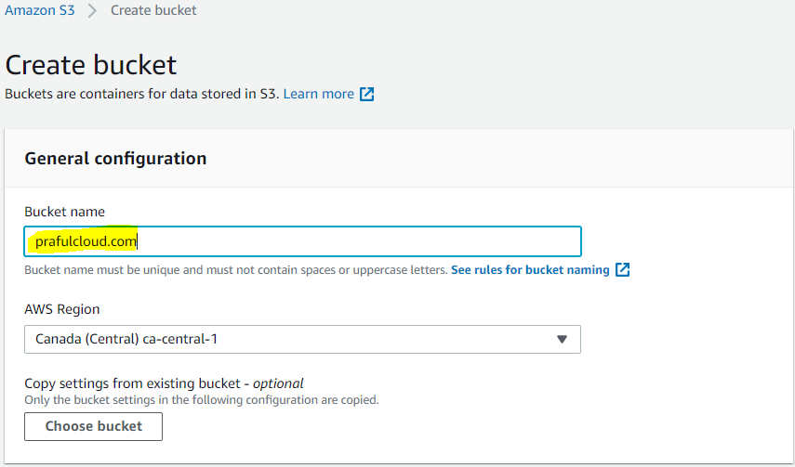

Set the following values:

Bucket name: prafulcloud.com with the AWS account number or another series of numbers at the end to make it globally unique

Region: US East (N. Virginia) us-east-1

In the Bucket settings for Block Public Access section, un-check Block all public access.

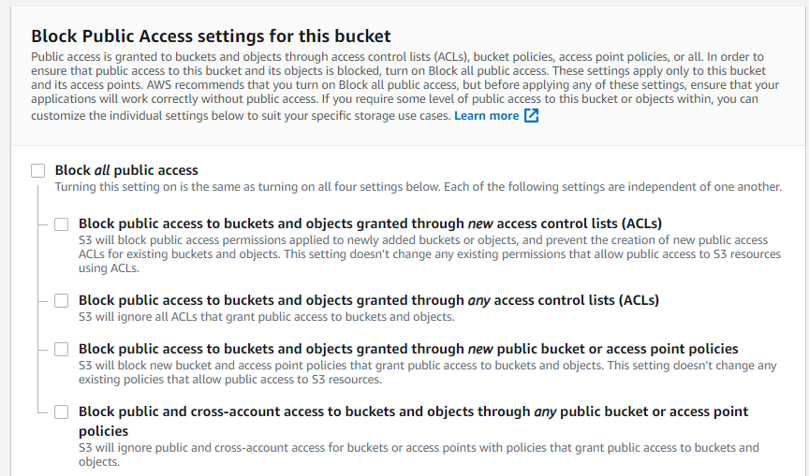

Ensure all four permissions restrictions beneath it are also un-checked.

Check the box to acknowledge that turning off all public access might result in the bucket and its objects becoming public.

Leave the rest of the settings as their defaults.

Click Create bucket.

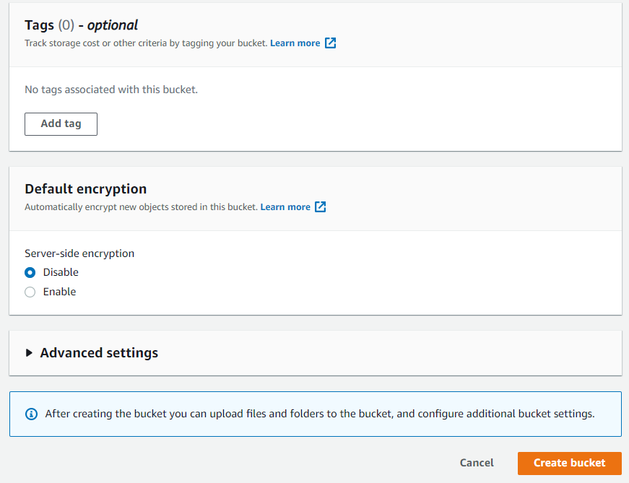

Select the bucket name.



Click Upload.

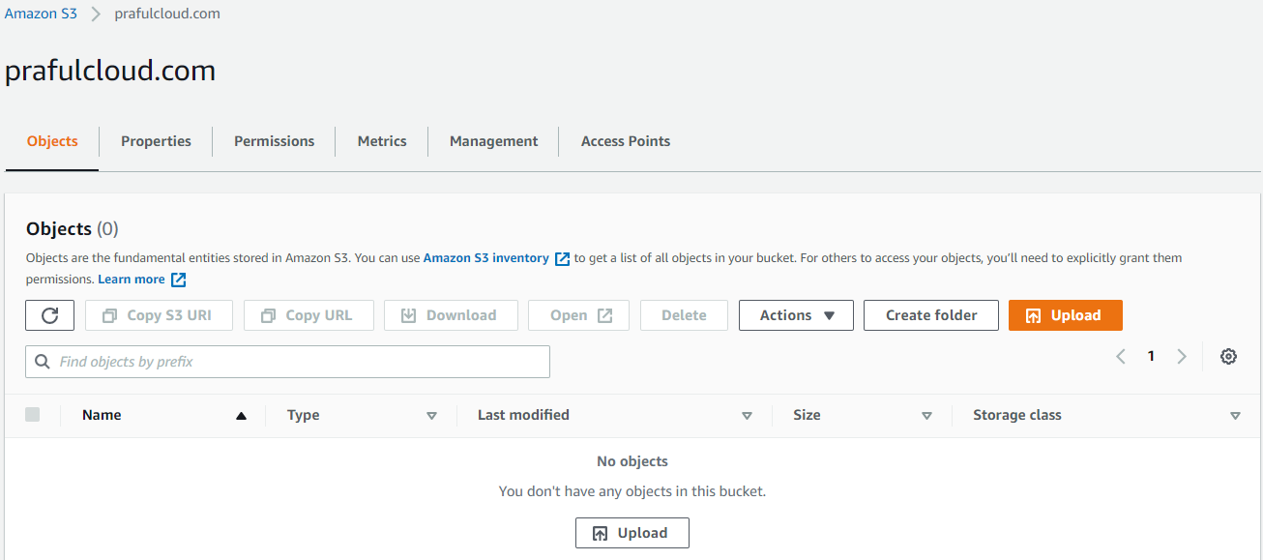

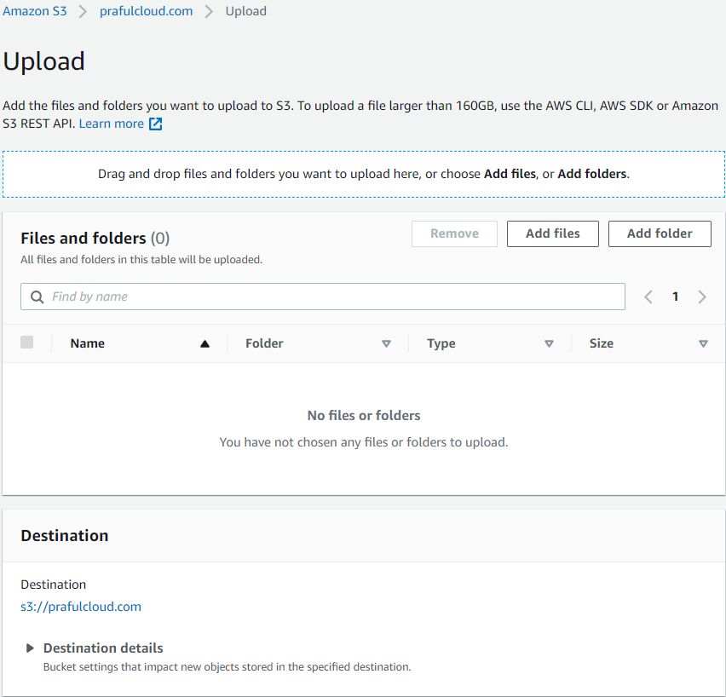

Click Add files, and upload your own or the error.html and index.html

Leave the rest of the settings as their defaults.

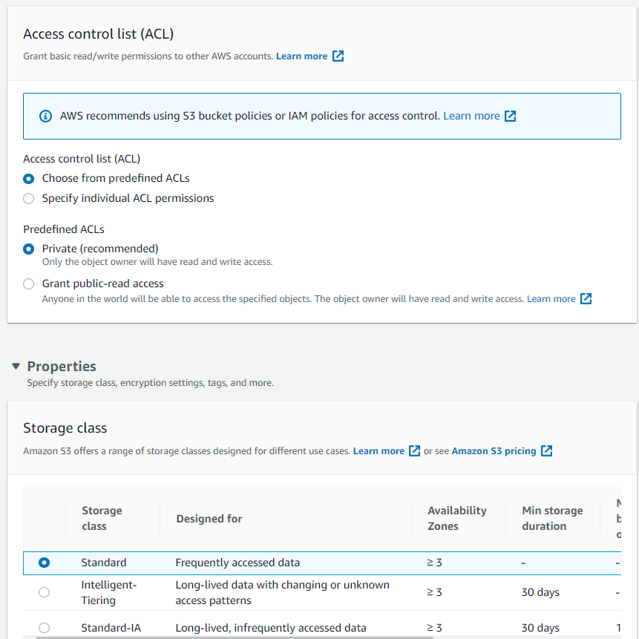

Click Upload.

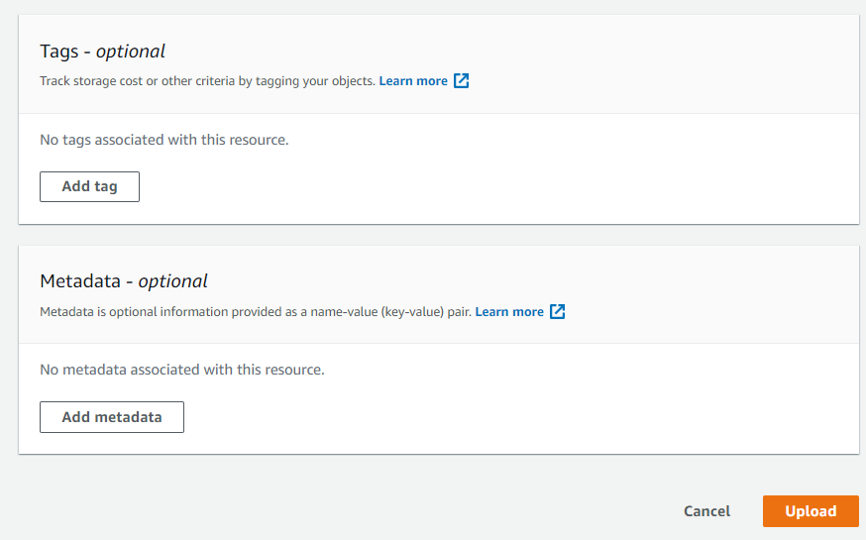

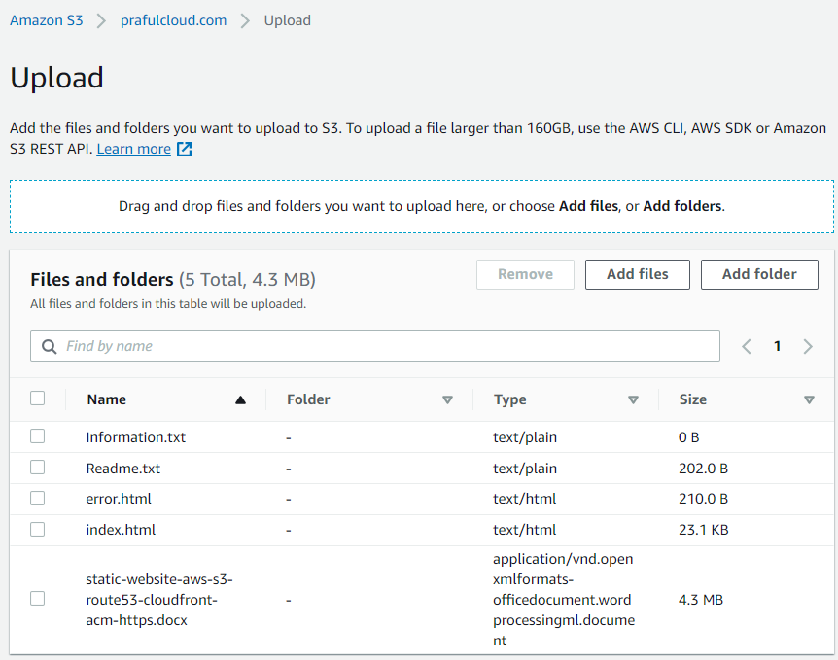

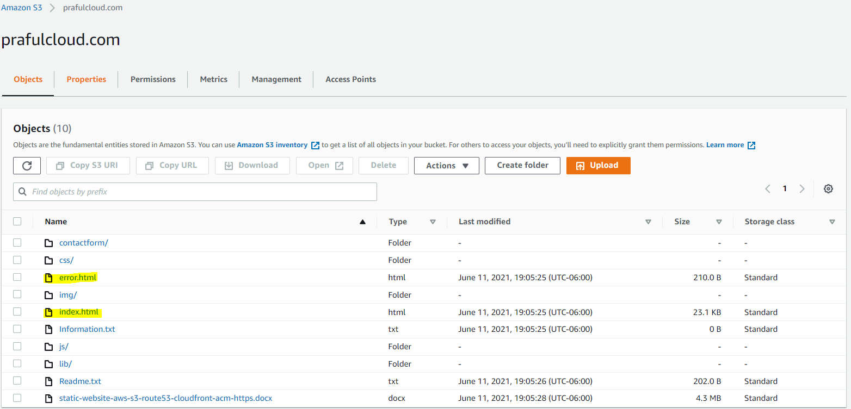

Click Exit in the upper right.

Enable Static Website Hosting

Click the Properties tab.

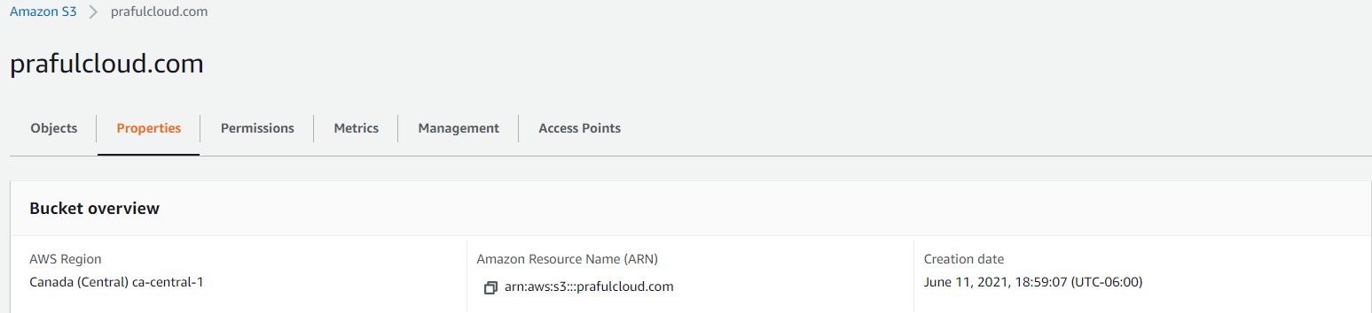

Scroll to the bottom of the screen to find the Static website hosting section.

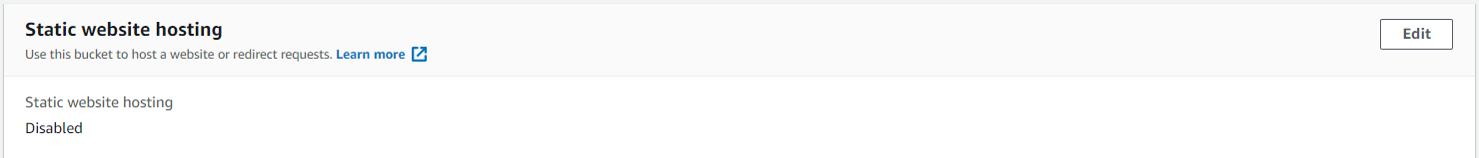

On the right in the Static website hosting section, click Edit.

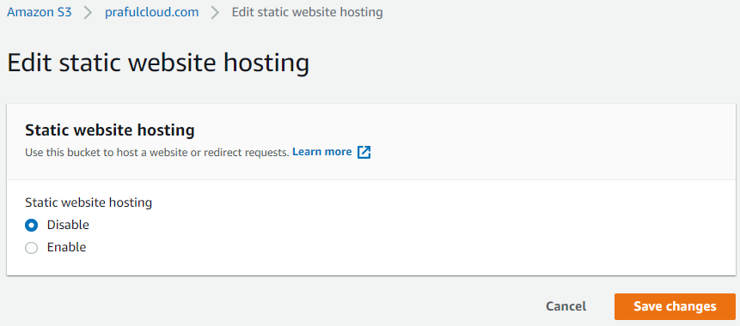

On the Edit static website hosting page, set the following values:

Static website hosting: Enable

Hosting type: Host a static website

Index document: index.html

Error document: error.html

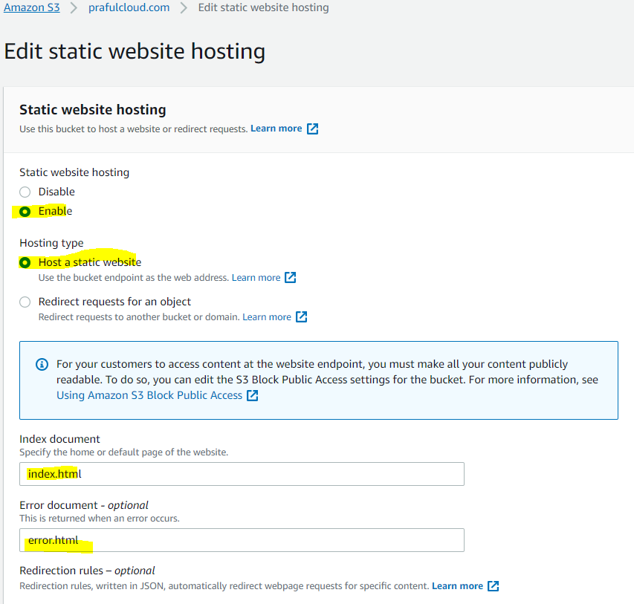

Click Save changes.

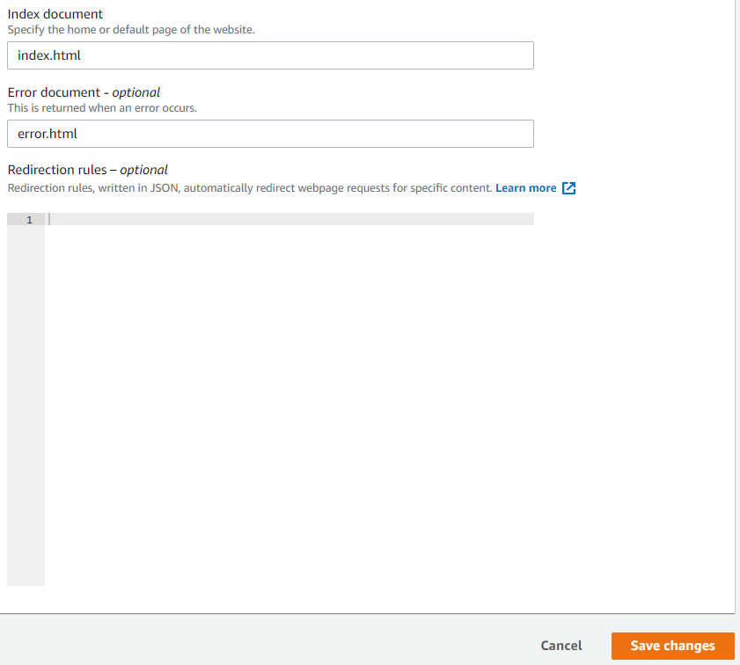

Scroll back down to the Static website hosting section.

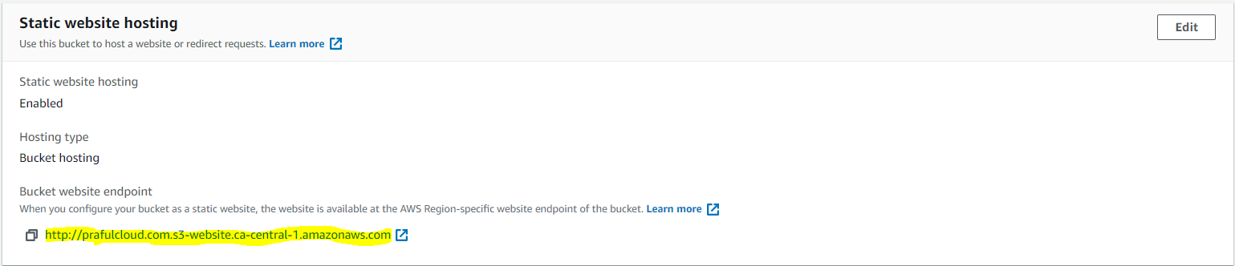

Open the listed endpoint URL in a new browser tab. We'll see a 403 Forbidden error message.

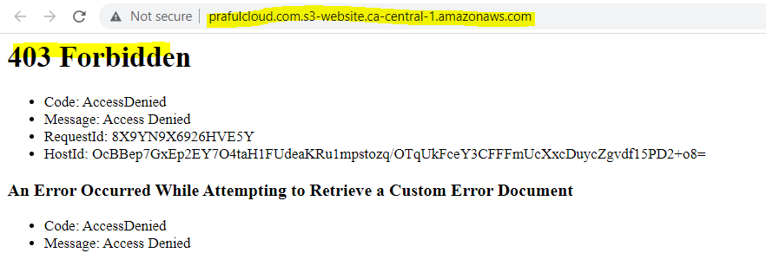

Apply Bucket Policy

Back in S3, click the Permissions tab.

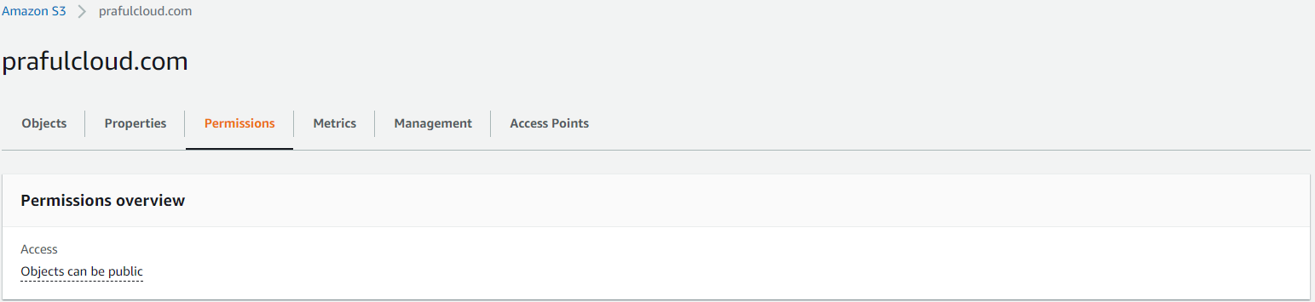

In the Bucket policy section, click Edit.

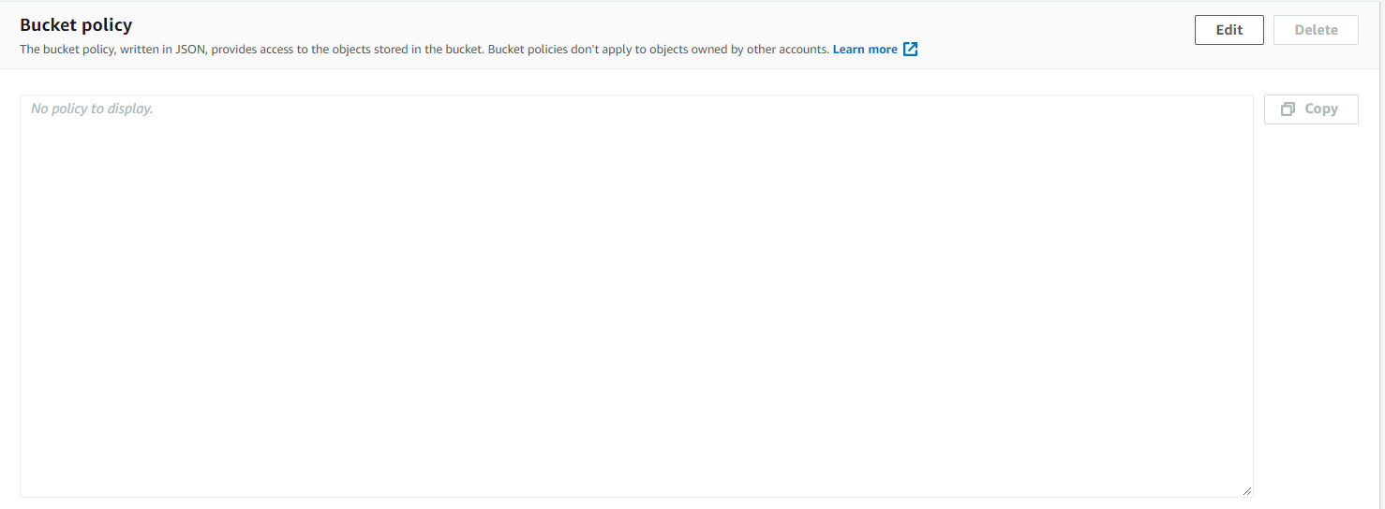

In the Policy box, enter the following JSON statement (replacing <BUCKET\_ARN> with the bucket ARN provided right above the Policy box):

Generate a Bucket policy using Policy generator

Find the ARN and copy

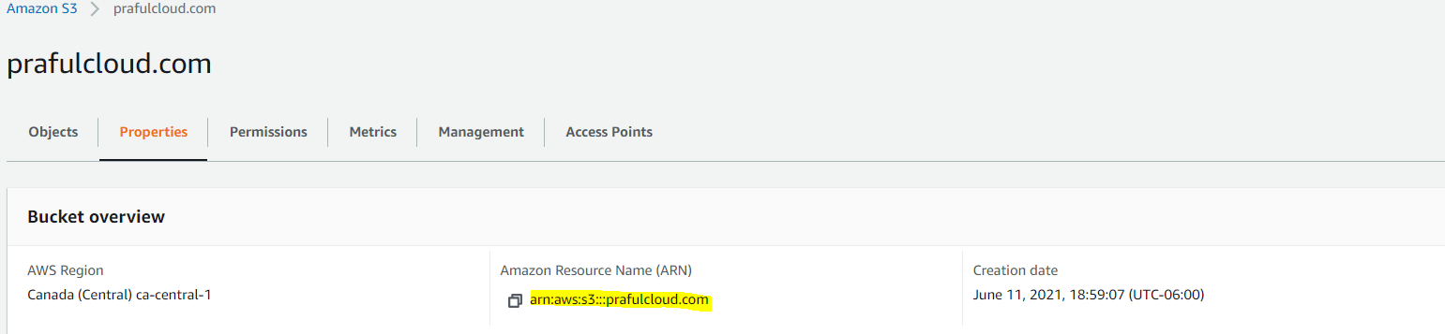

Go to Policy Generator

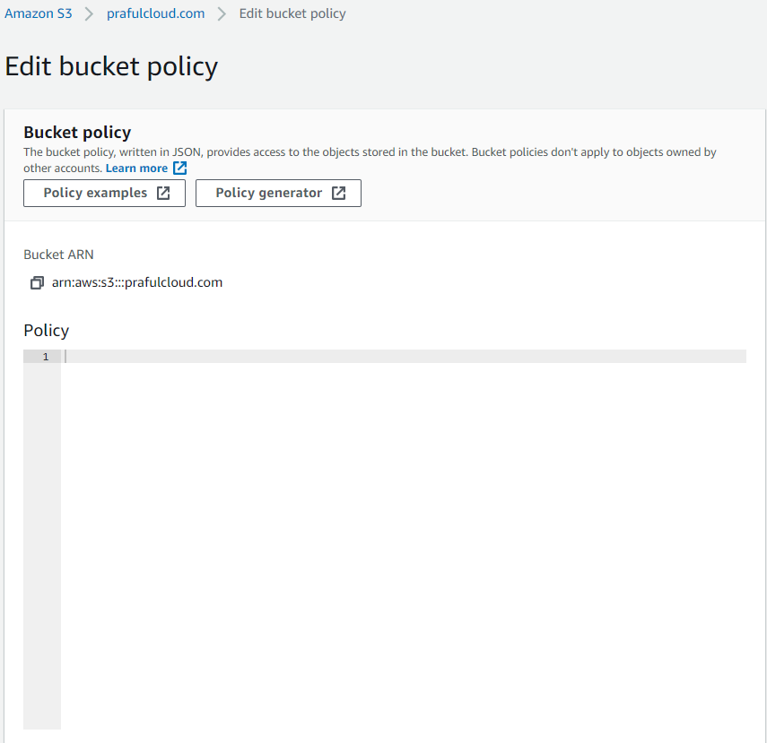

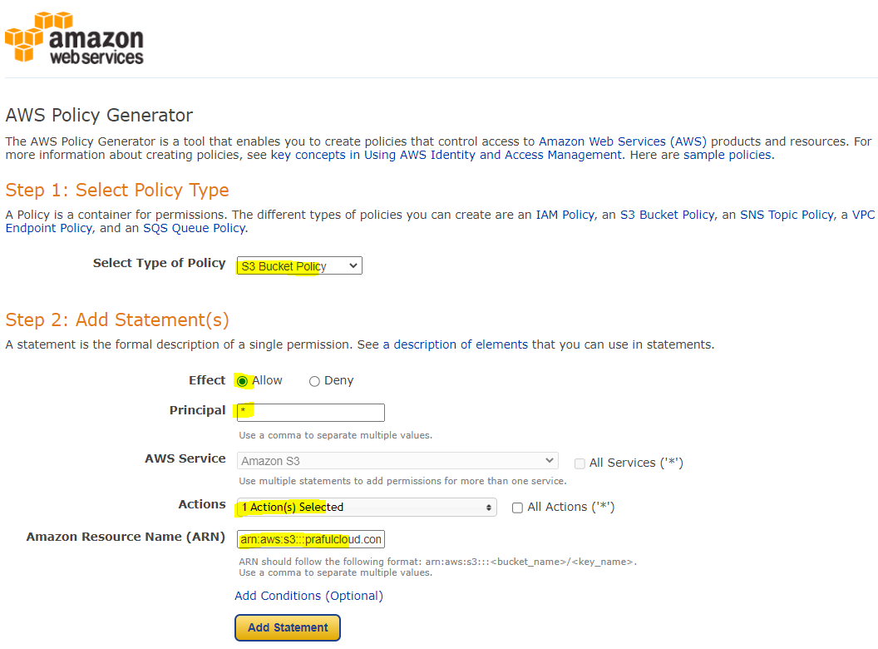

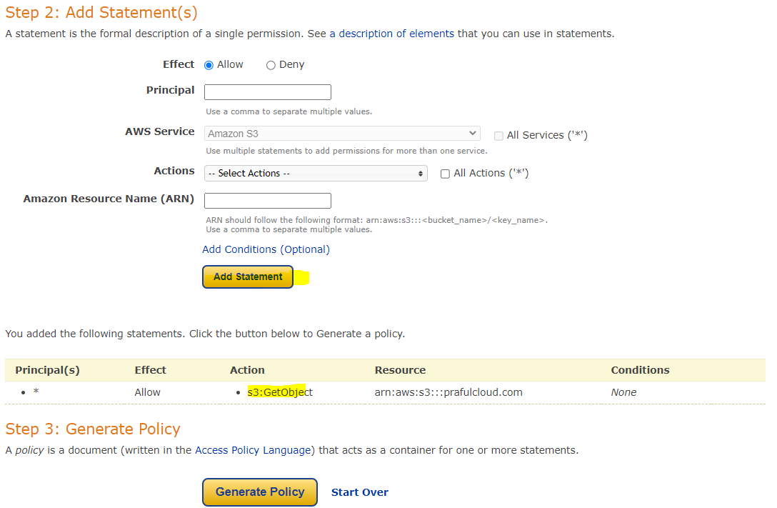

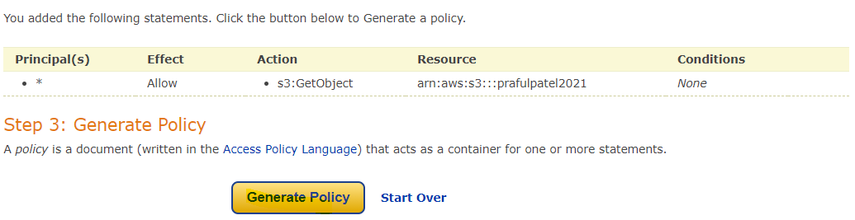

\* 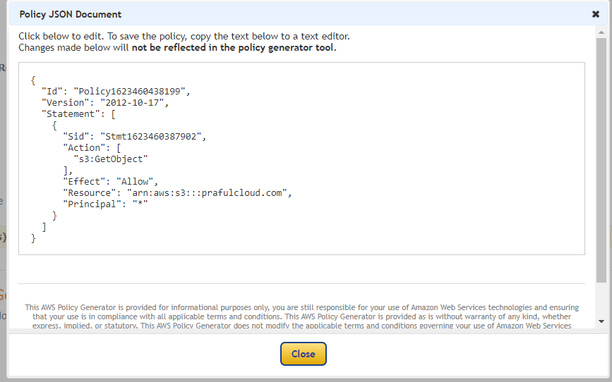

{

"Id": "Policy1623460438199",

"Version": "2012-10-17",

"Statement": [

{

"Sid": "Stmt1623460387902",

"Action": [

"s3:GetObject"

],

"Effect": "Allow",

"Resource": "arn:aws:s3:::prafulcloud.com",

"Principal": "\*"

}

]

}

{

{

"Version": "2012-10-17",

"Statement": [

{

"Sid": "PublicReadGetObject",

"Effect": "Allow",

"Principal": "\*",

"Action": "s3:GetObject",

"Resource": "arn:aws:s3:::prafulcloud.com/\*"

}

]

}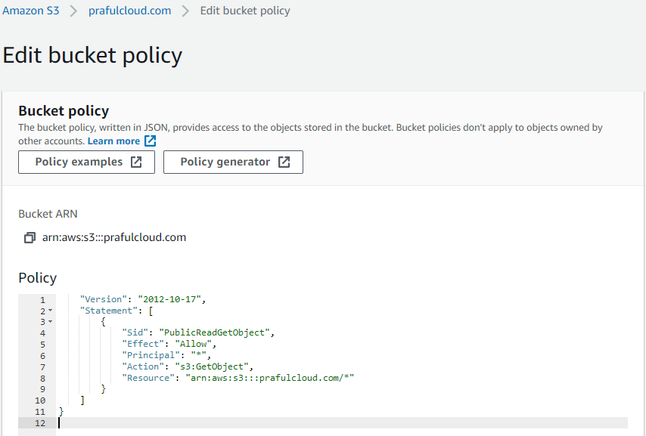

Note: Ensure the trailing /\* is present so the policy applies to all objects within the bucket.

{

"Id": "Policy1623022285875",

"Version": "2012-10-17",

"Statement": [

{

"Sid": "Stmt1623022231437",

"Action": [

"s3:GetObject"

],

"Effect": "Allow",

"Resource": "arn:aws:s3:::prafulpatel2021/\*­",

"Principal": "\*"

}

]

}

Click Save changes.

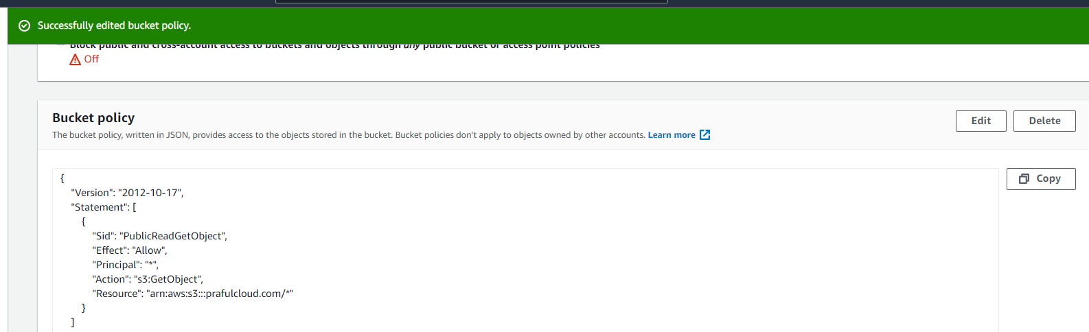

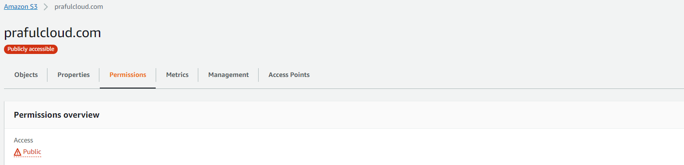

Refresh the browser tab with the static website (the endpoint URL we opened a minute ago). This time, it should load the site correctly.

Before Bucket Policy update Test URL :

Output: Error

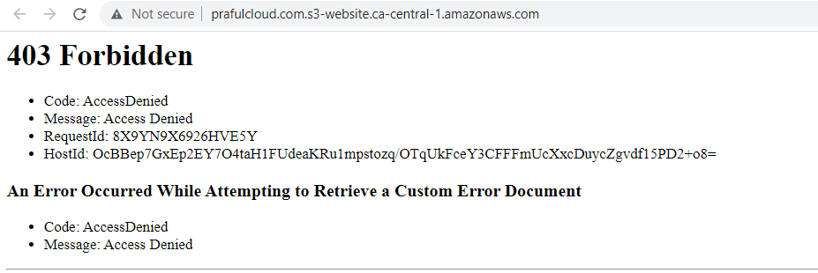

After Bucket Policy update Test URL :

Output: Error

**Test Web URL:** index.html

<http://prafulcloud.com.s3-website.ca-central-1.amazonaws.com/>

After Refresh Verify that the static web page URL is loaded correctly and web page is displayed

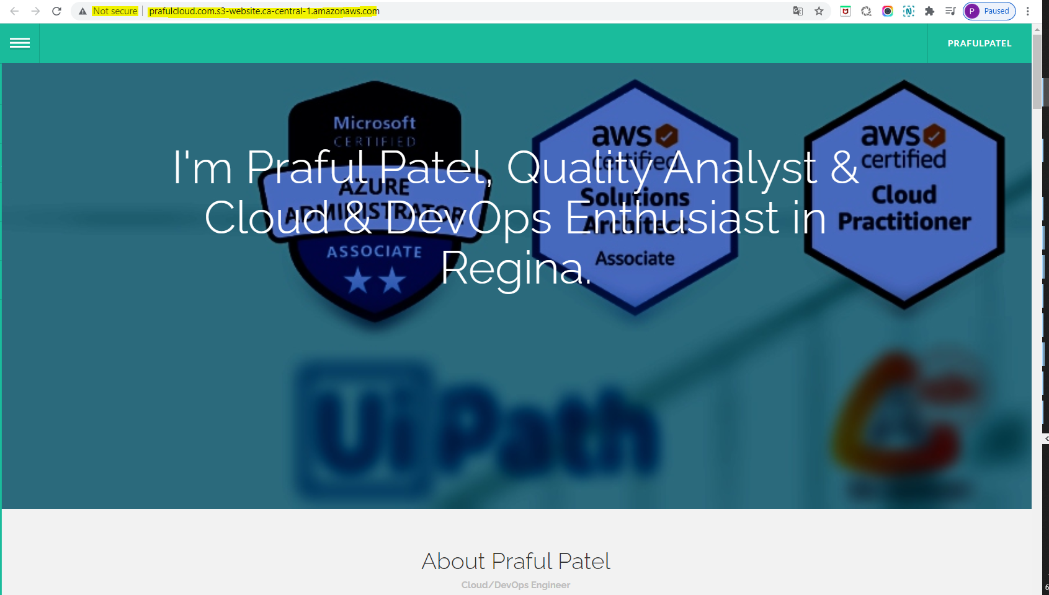

Add a / at the end of the URL and some random letters (anything that's knowingly an error). This will display our error.html info.

**Test Web URL:** error.html

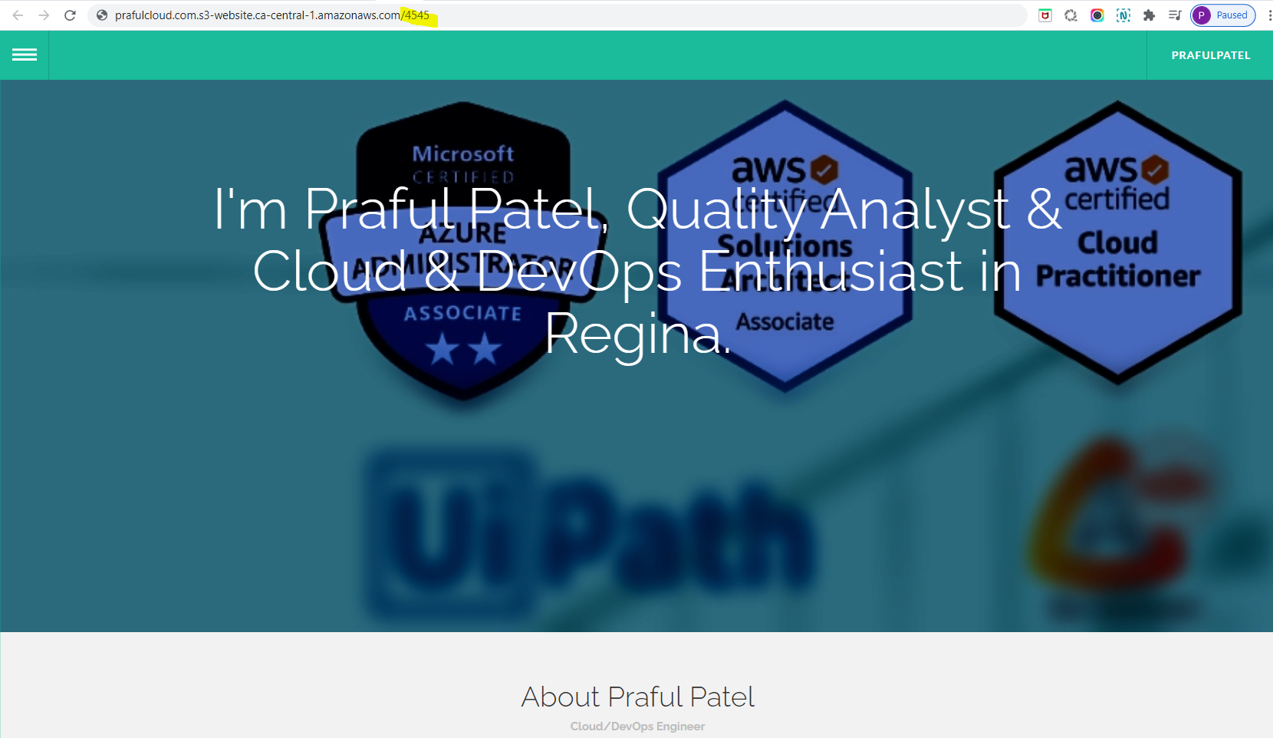

Do Refresh the URL after entering /222 and validate that the Error.html page is displayed

**Redirect for an HTTP error**

http://prafulpatel2021.s3-website-us-east-1.amazonaws.com/2343

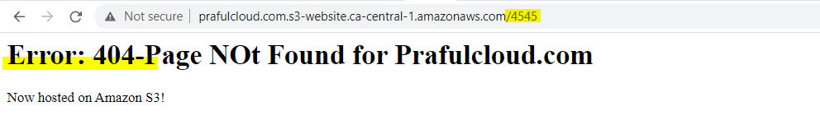

**Useful resources & Links:**

<https://github.com/prafulpatel16/aws-projects/tree/main/creating-a-static-webiste-using-aws-s3>

<https://docs.aws.amazon.com/AmazonS3/latest/userguide/WebsiteHosting.html>

**Project 2 : Create a static website using aws S3 with enabling & logging web server traffic logs.**

**Objective:**

To access Logging web traffic

**To enable server access logging for your static website bucket**

1. Open the Amazon S3 console at <https://console.aws.amazon.com/s3/>.
2. In the same Region where you created the bucket that is configured as a static website, create a bucket for logging, for example logs.example.com.

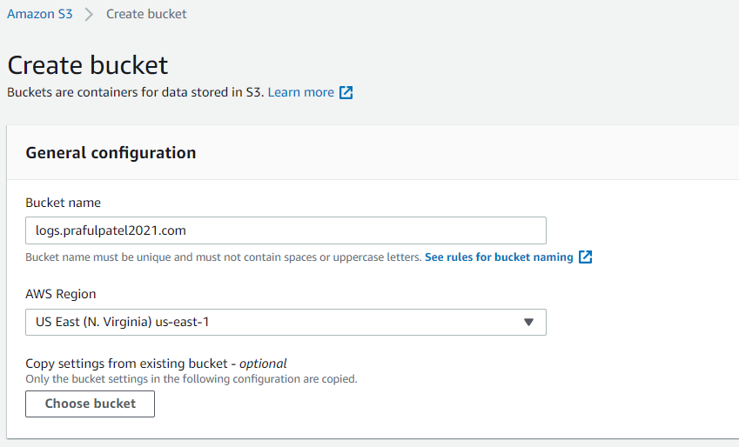

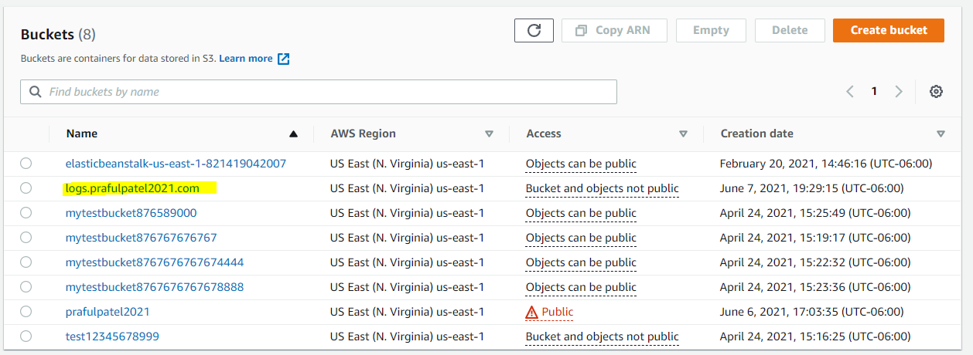

1. Create a folder for the server access logging log files (for example, logs).

When you group your log data files in a folder, they are easier to locate.

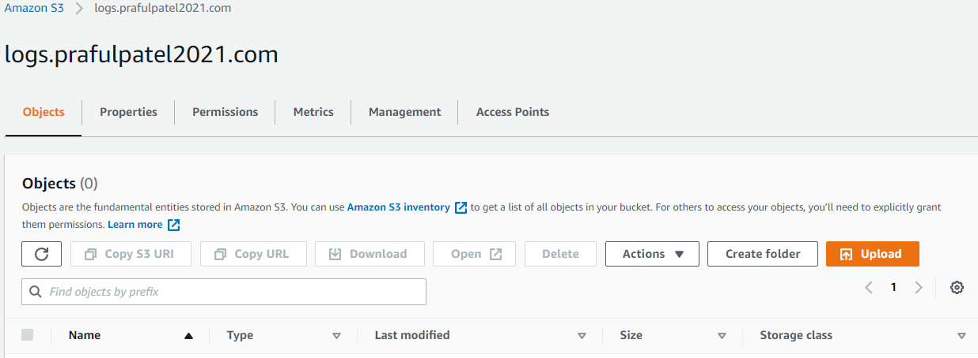

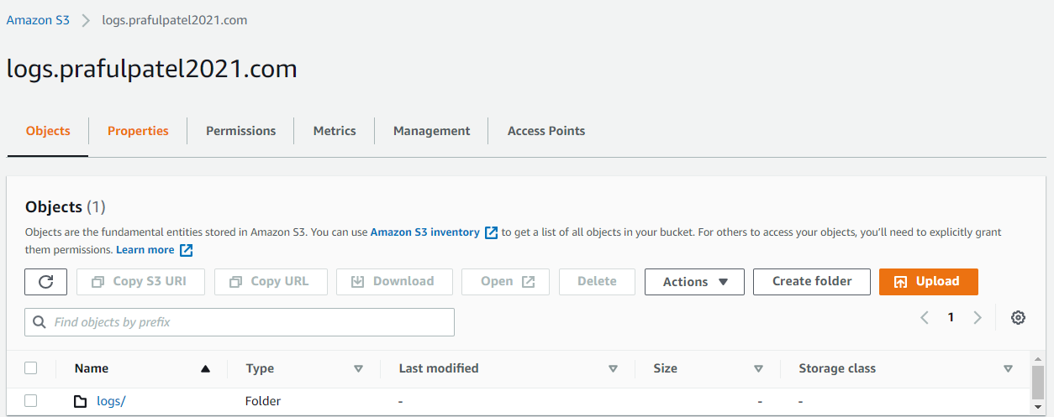

1. (Optional) If you want to use CloudFront to improve your website performance, create a folder for the CloudFront log files (for example, cdn).
2. In the **Buckets** list, choose your bucket.

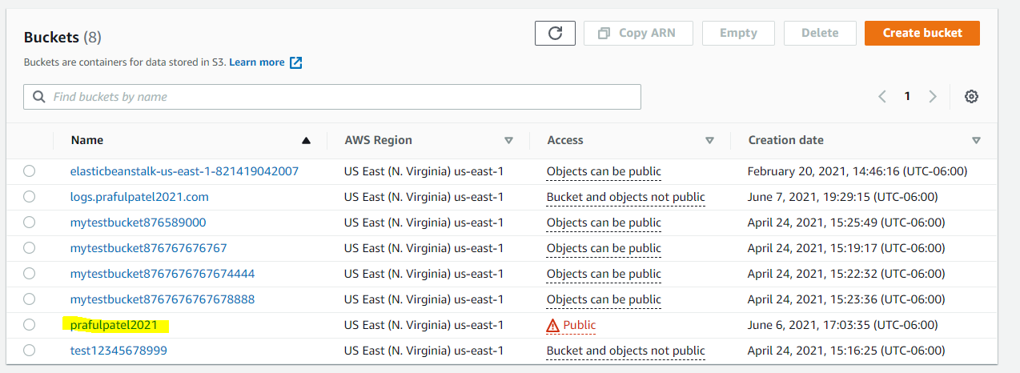

1. Choose **Properties**.

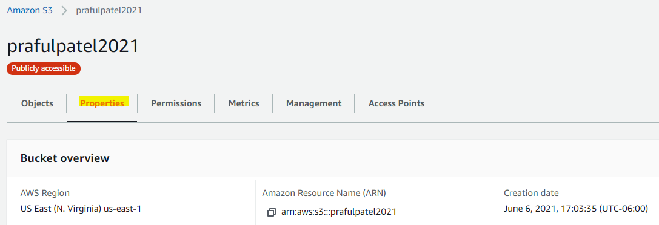

1. Under **Server access logging**, choose **Edit**.

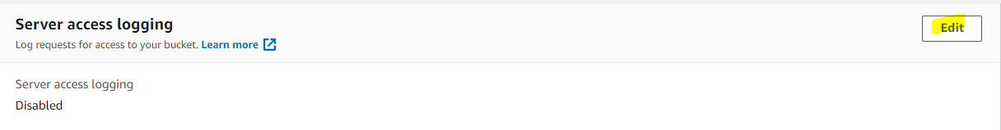

1. Choose **Enable**.

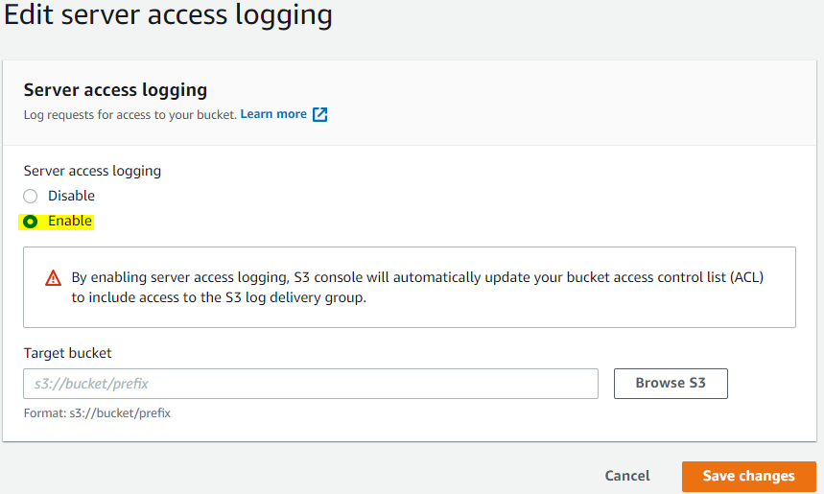

1. Under the **Target bucket**, choose the bucket and folder destination for the server access logs:
   * Browse to the folder and bucket location:
     1. Choose **Browse S3**.

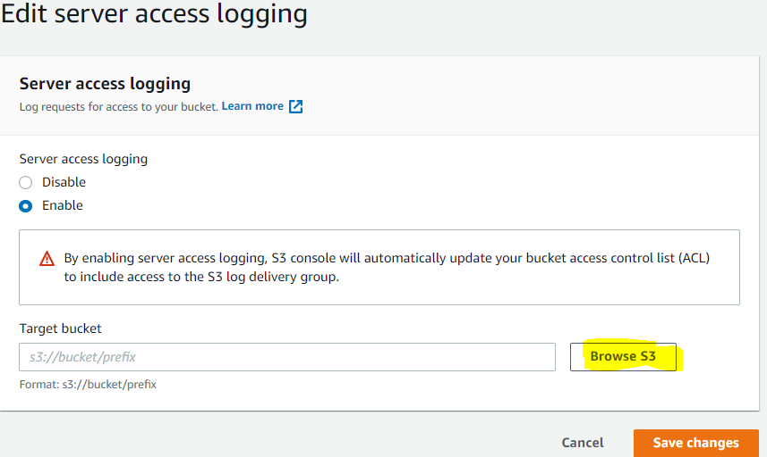

* + 1. Choose the bucket name, and then choose the logs folder.
    2. Choose **Choose path**.
  + Enter the S3 bucket path, for example, **s3://logs.example.com/logs/**.

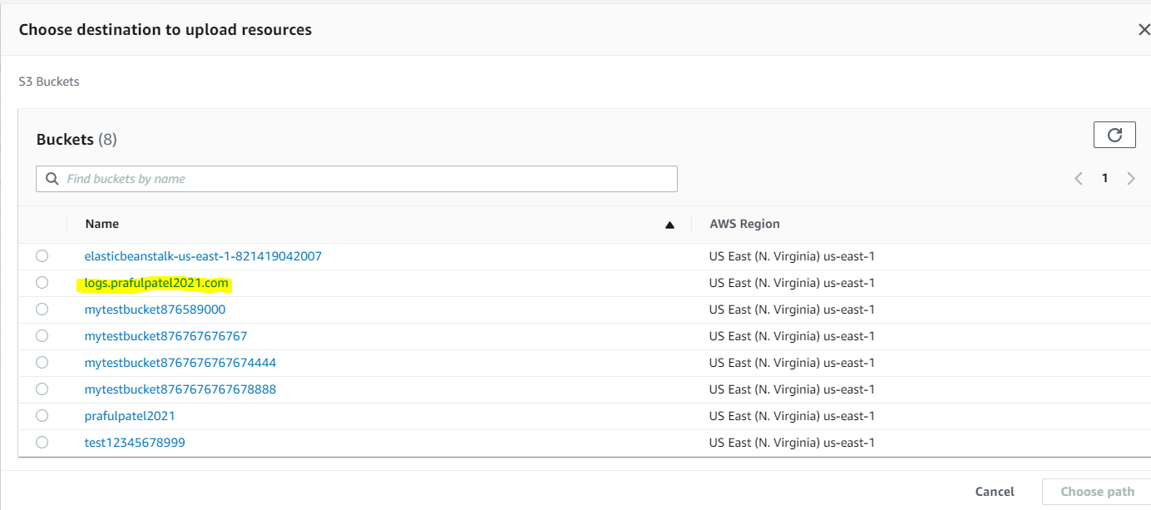

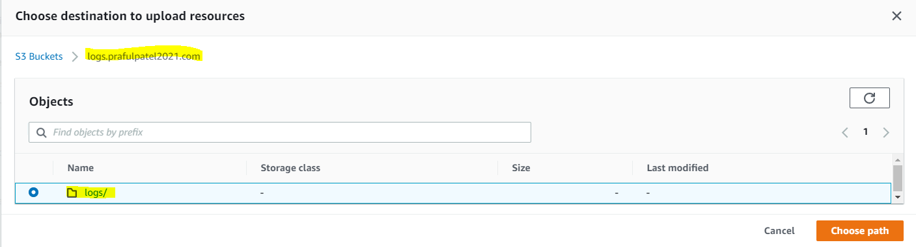

1. Choose **Save changes**.

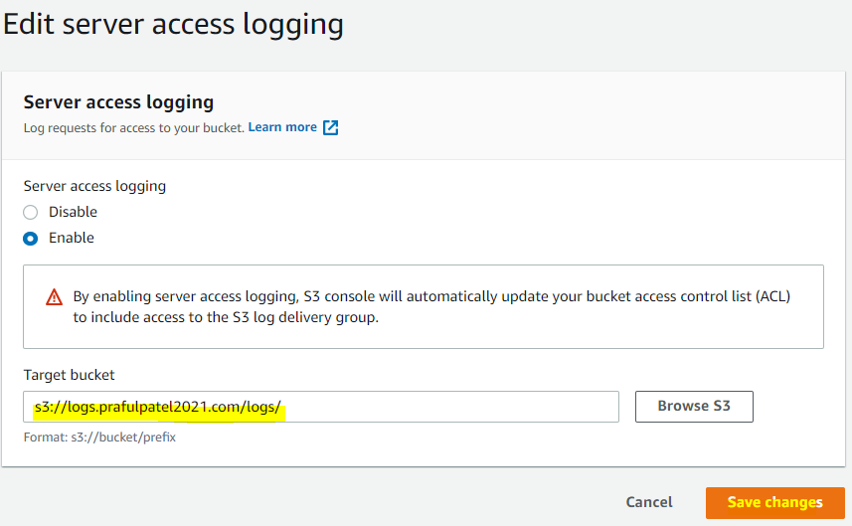

In your log bucket, you can now access your logs. Amazon S3 writes website access logs to your log bucket every 2 hours.

Verify Output that logs has been collected.

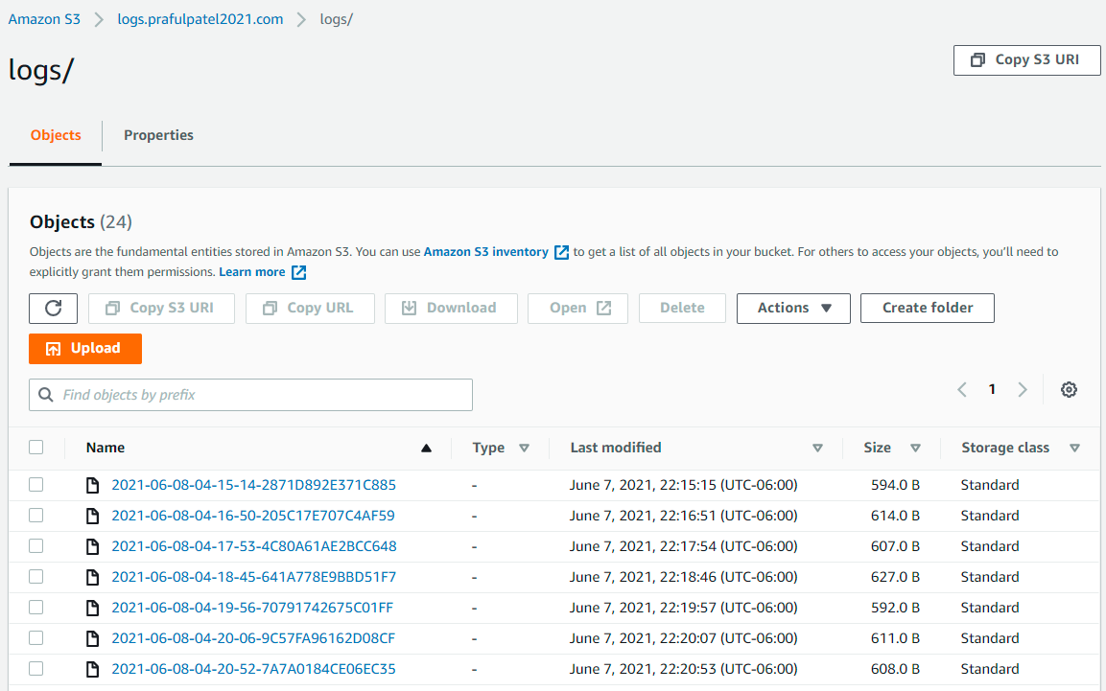



Useful Links:

<https://docs.aws.amazon.com/AmazonS3/latest/userguide/LoggingWebsiteTraffic.html>

**Task: 3 Create a Custom Domain and attach to static website**

Objective:

To deploy static website using custom domain

Note:

Domain is already created so one hosted zone is displayed

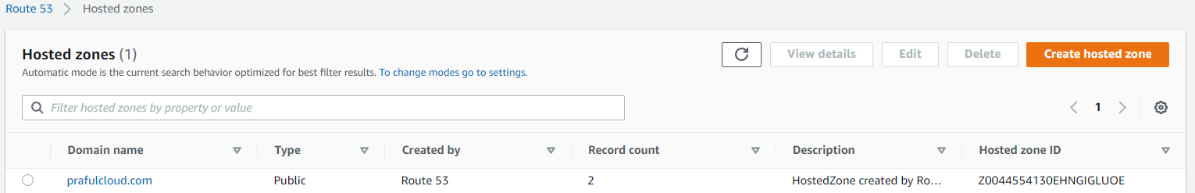

Locate the cursor on hosted zone

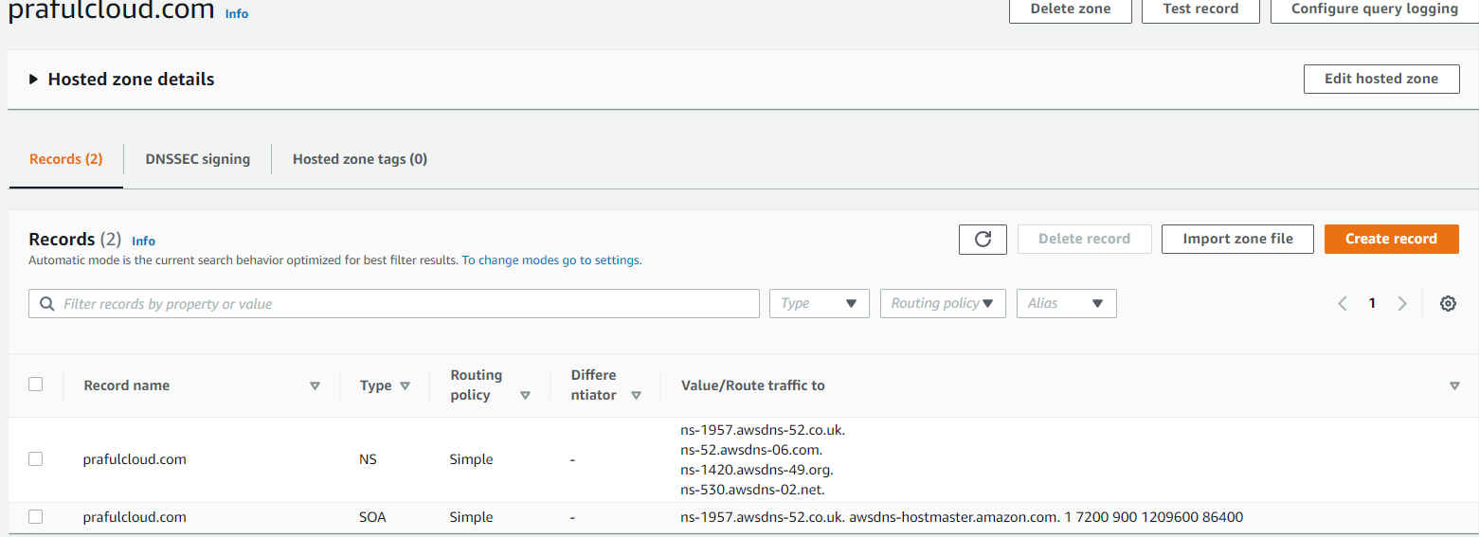

Create a record set

Click on Create record

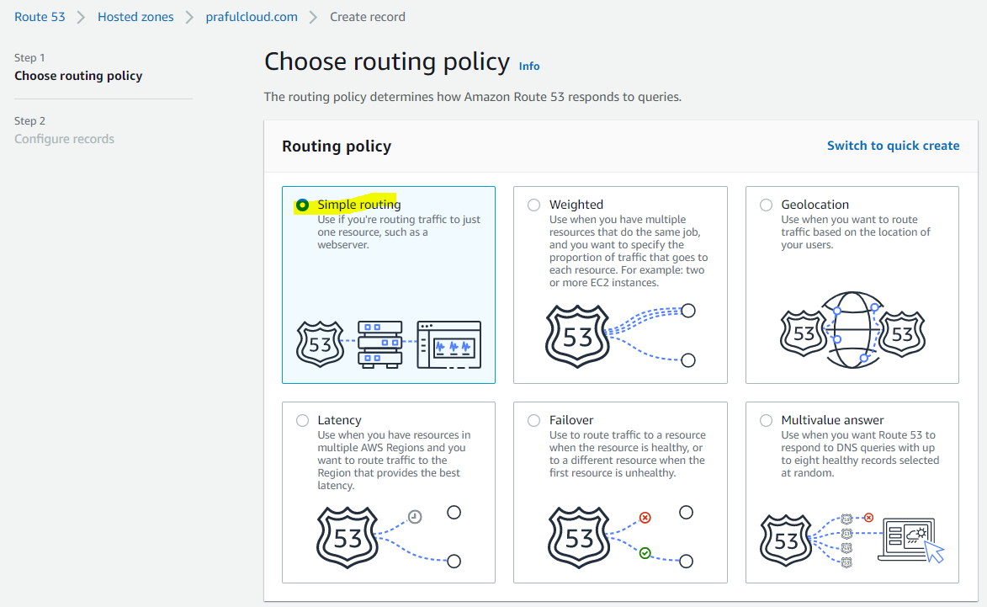

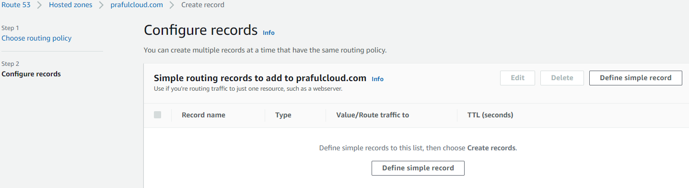

Set up a A record set

Type the same bucket name under region as s3 endpoin

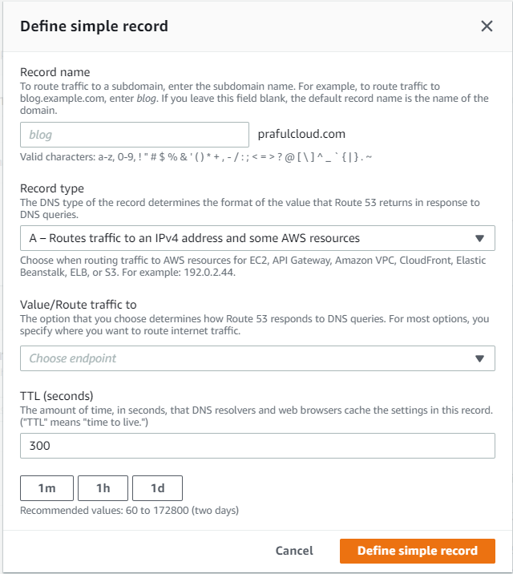

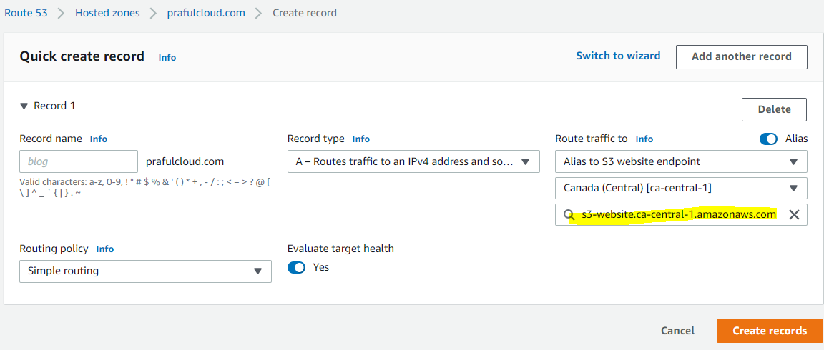

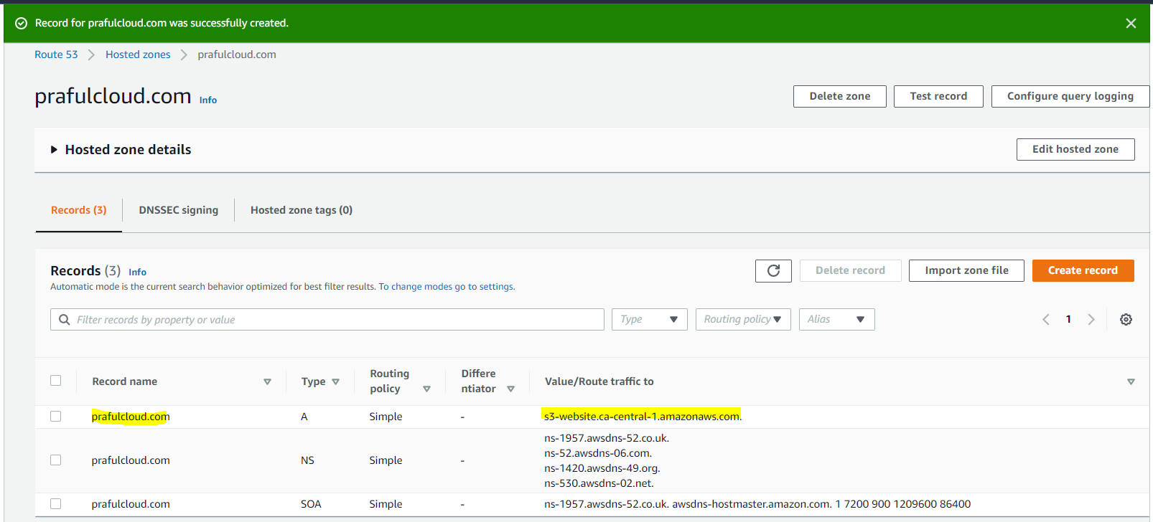

Test Custom Domain URL: prafulcloud.com

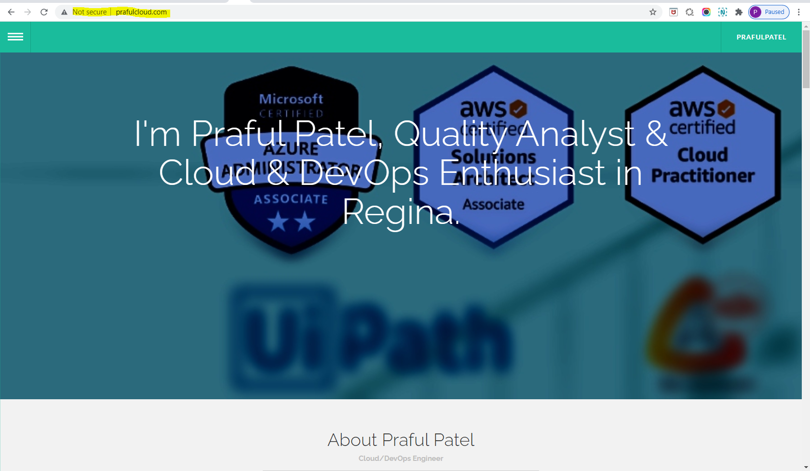

Page redirects to the subdomain www.prafulcloud.com

Configure www to the custom domain

<http://www.prafulcloud.com/>

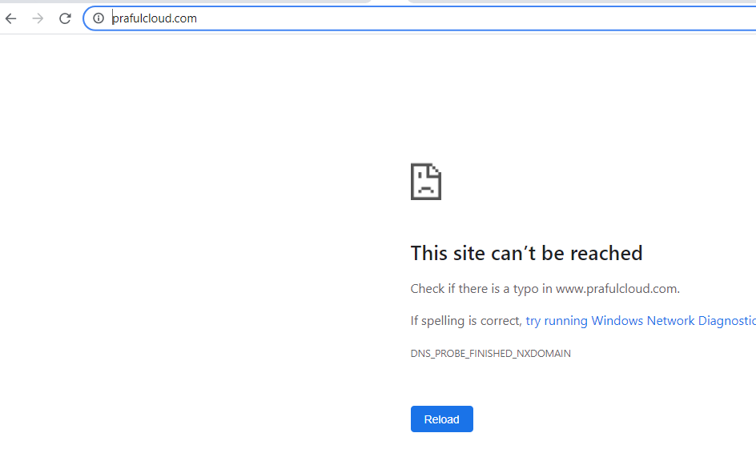

Create a new bucket

Name: [www.prafulcloud.com](http://www.prafulcloud.com)

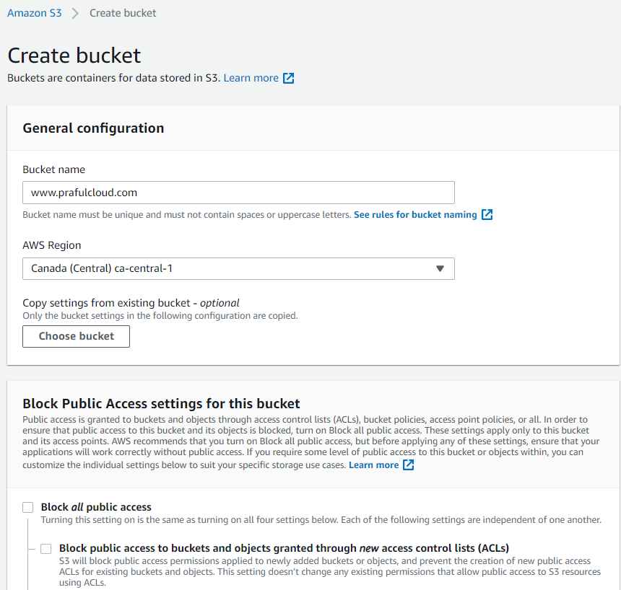

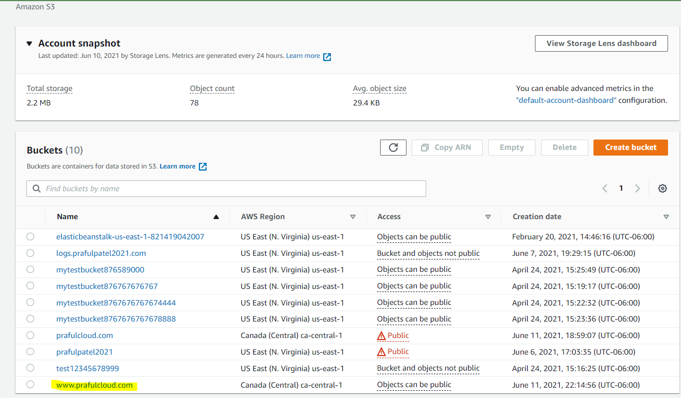

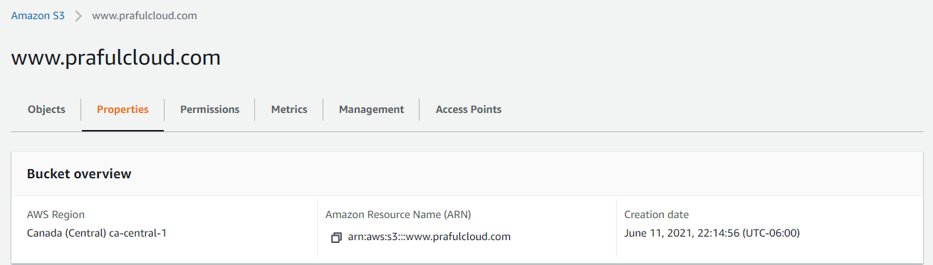

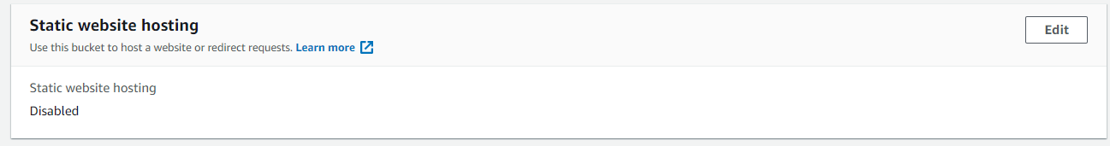

Select Http as S3 does not support Https

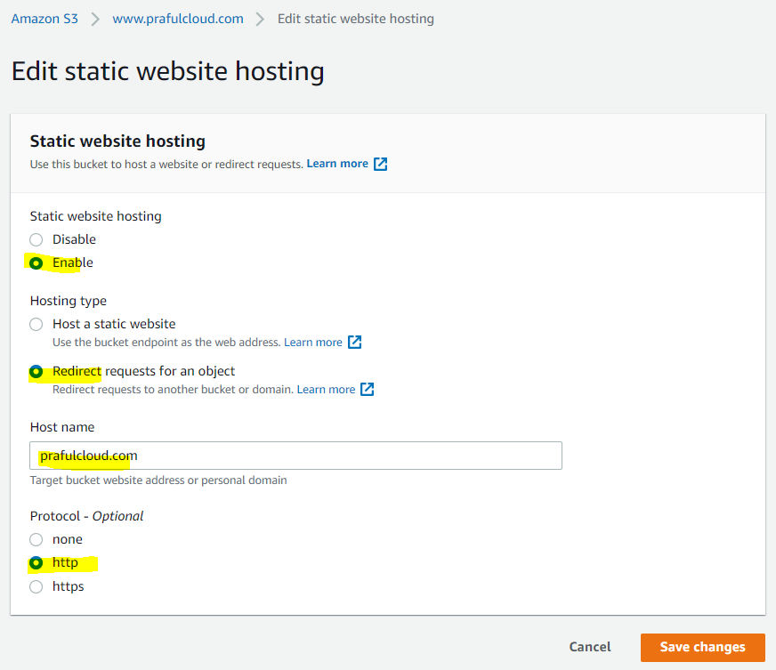

Go to Route53

Create A record set

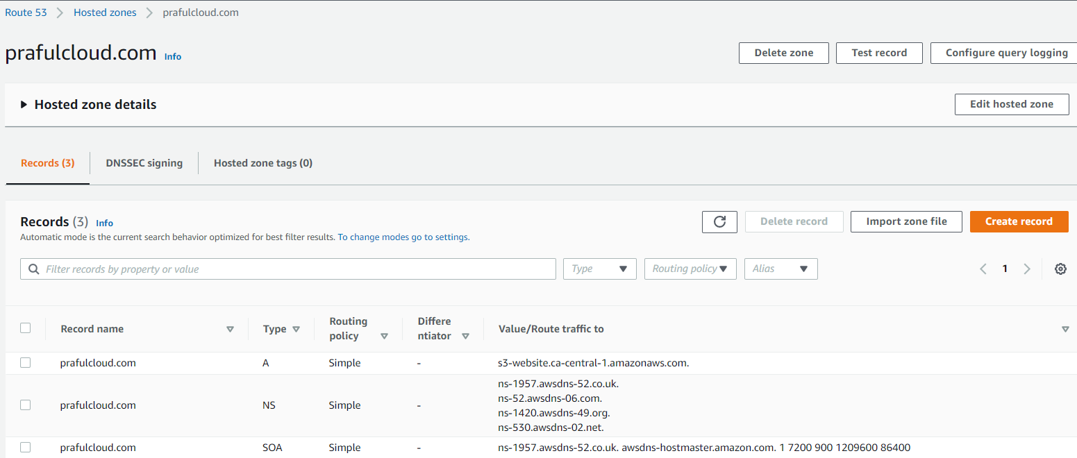

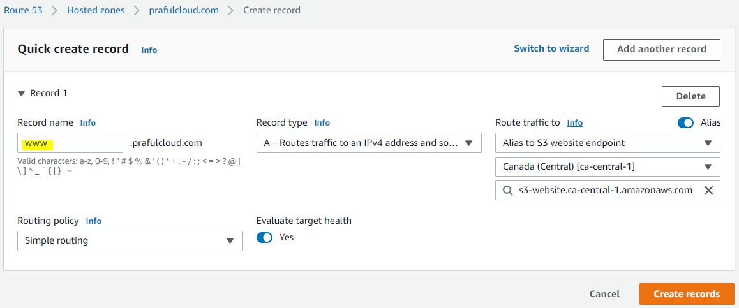

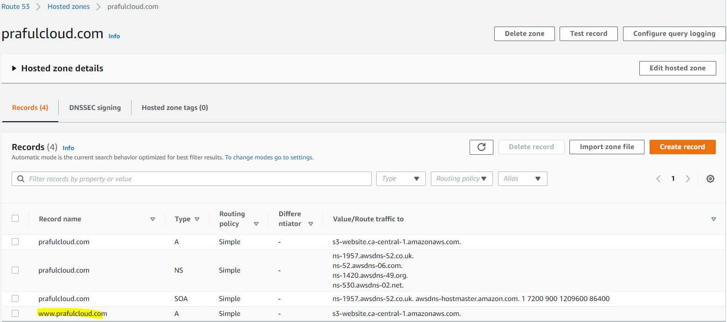

Test Url:

[www.prafulcloud.com](http://www.prafulcloud.com)

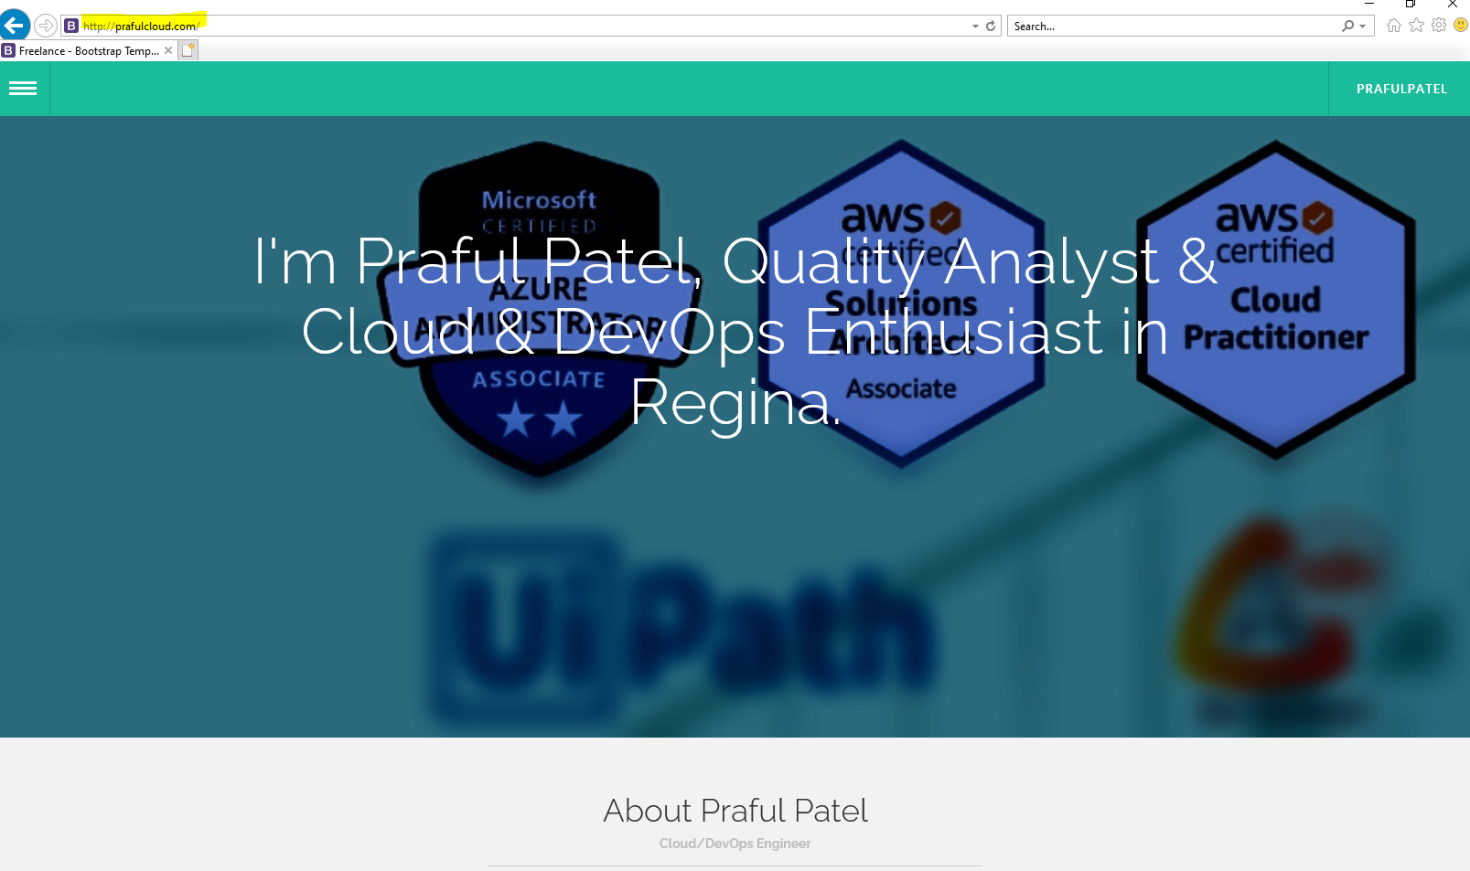

Setting up CDN Cloudfront service

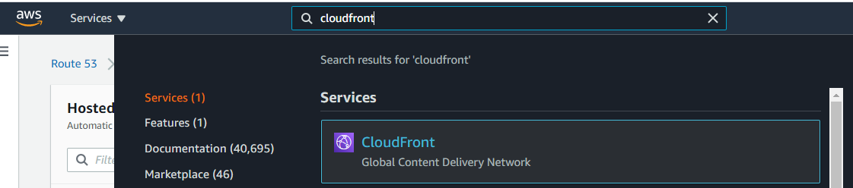

Click on Cloudfront

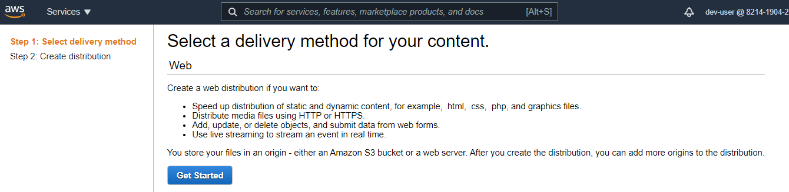

Select the desired bucket name

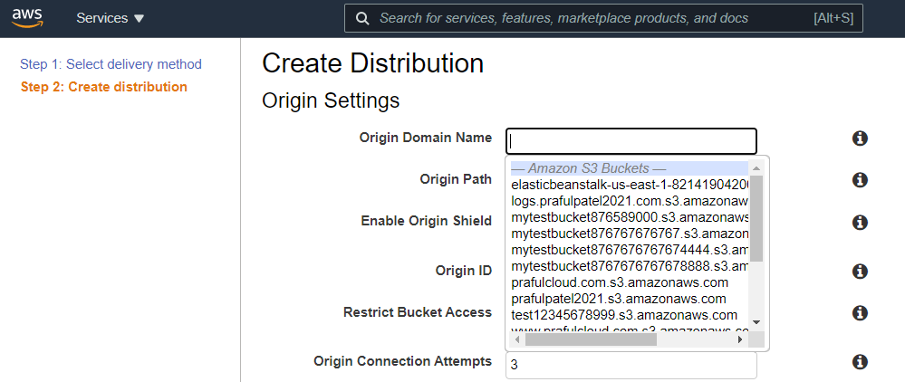

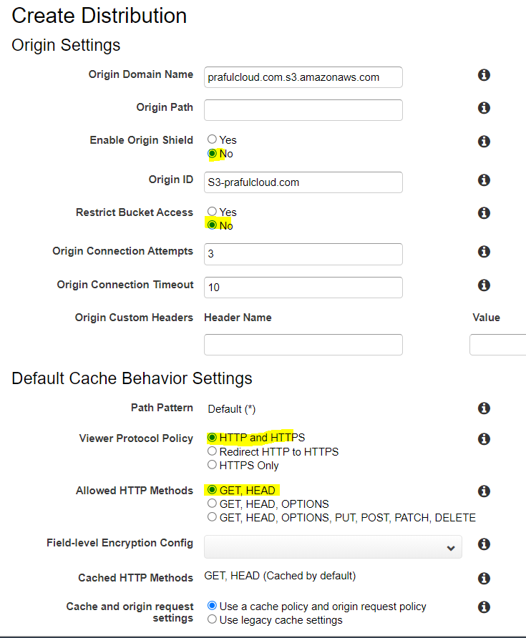

Got a certificate error

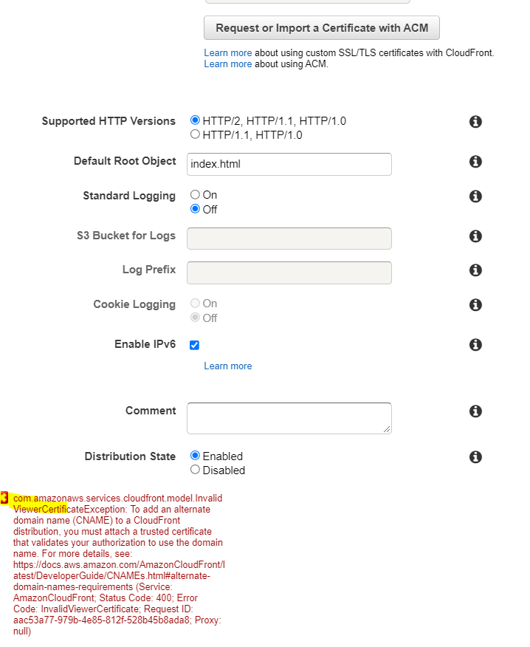

Create a certificate for the website

Go to Certificate Manager

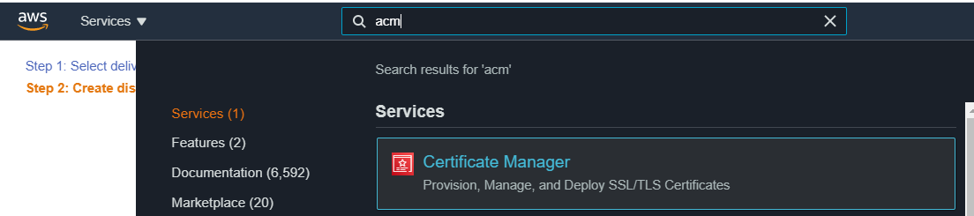

Select a Provision Certificate

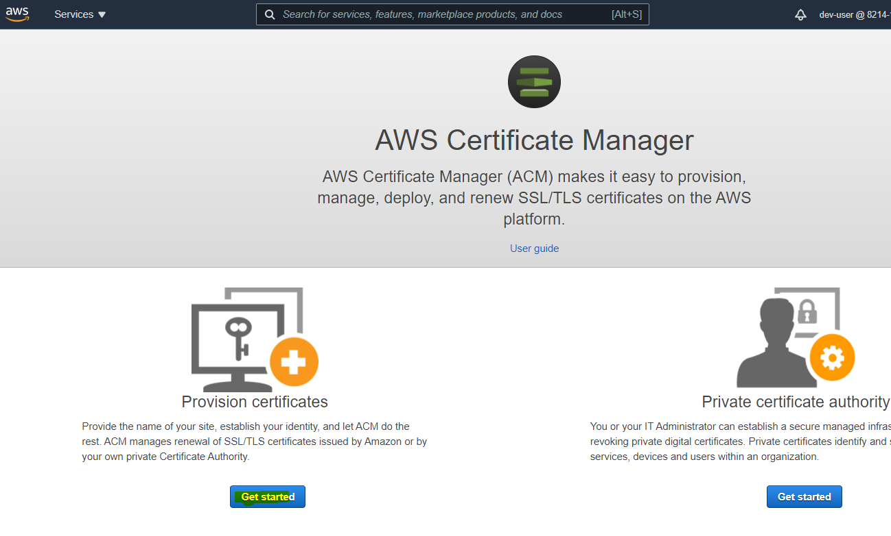

Click on Request a Certificate

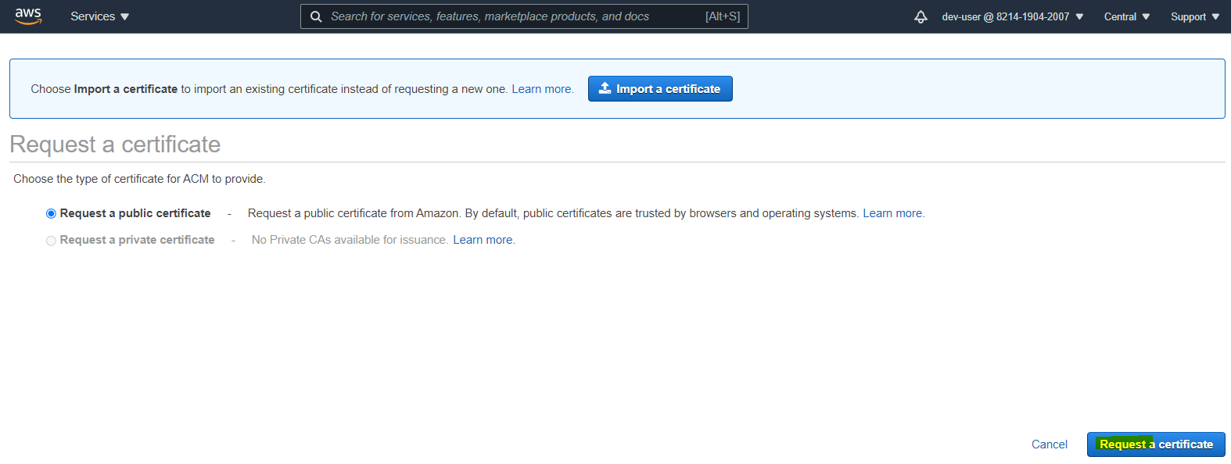

Enter the domain names

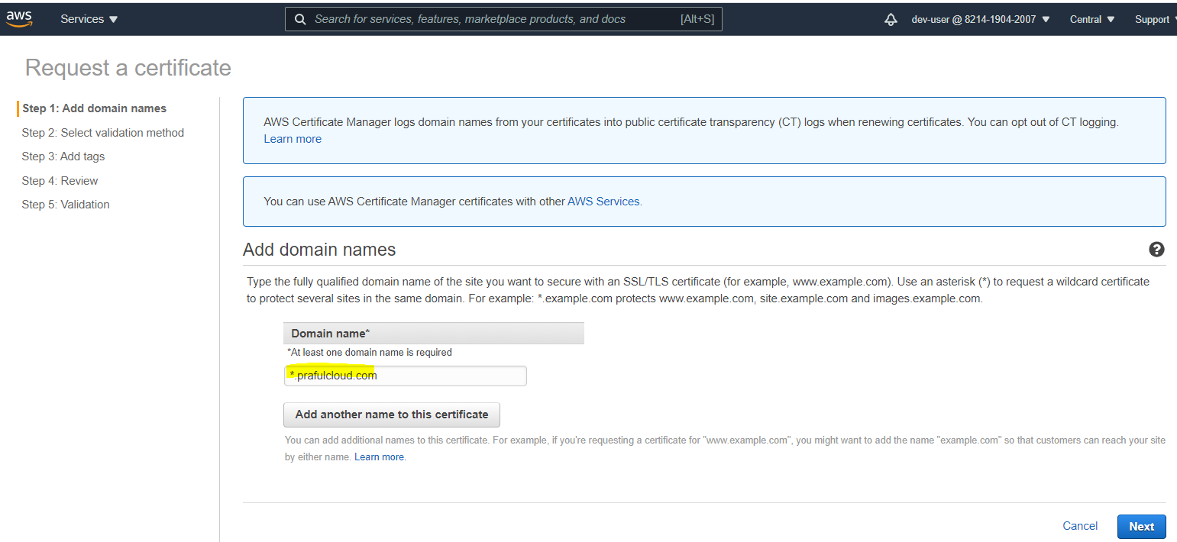

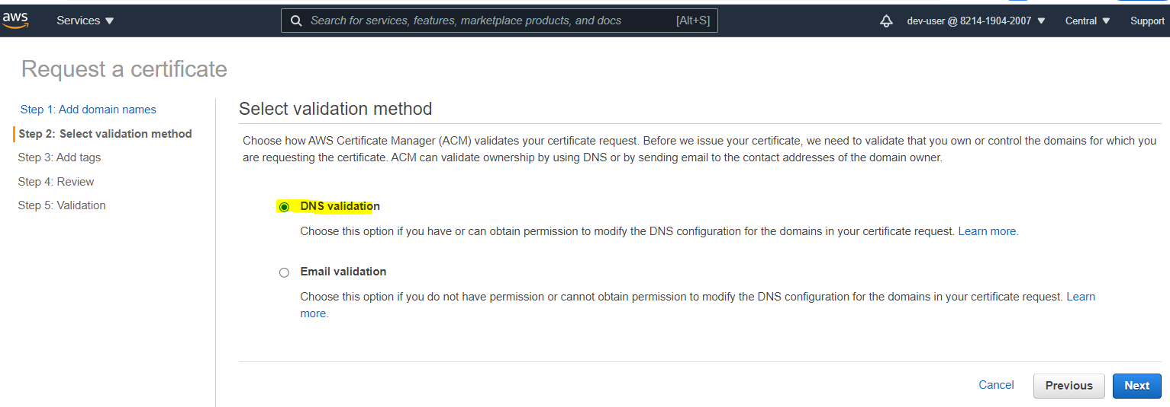

Add a Tag

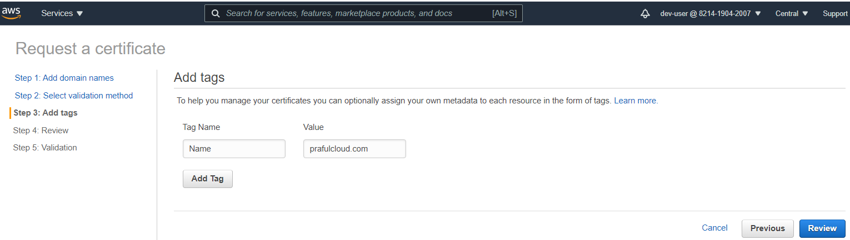

Click on confirm and request

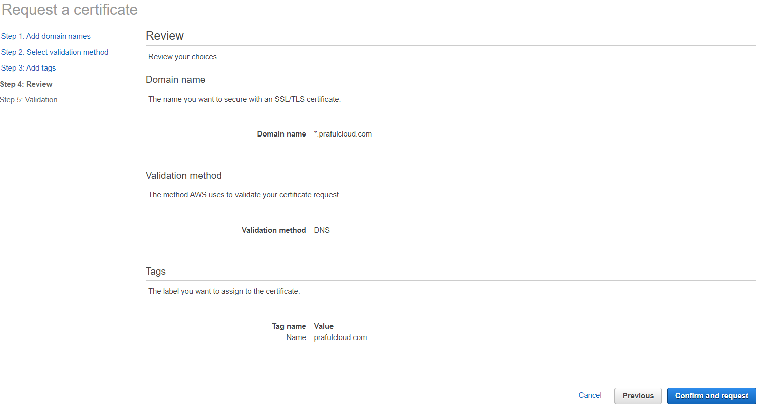

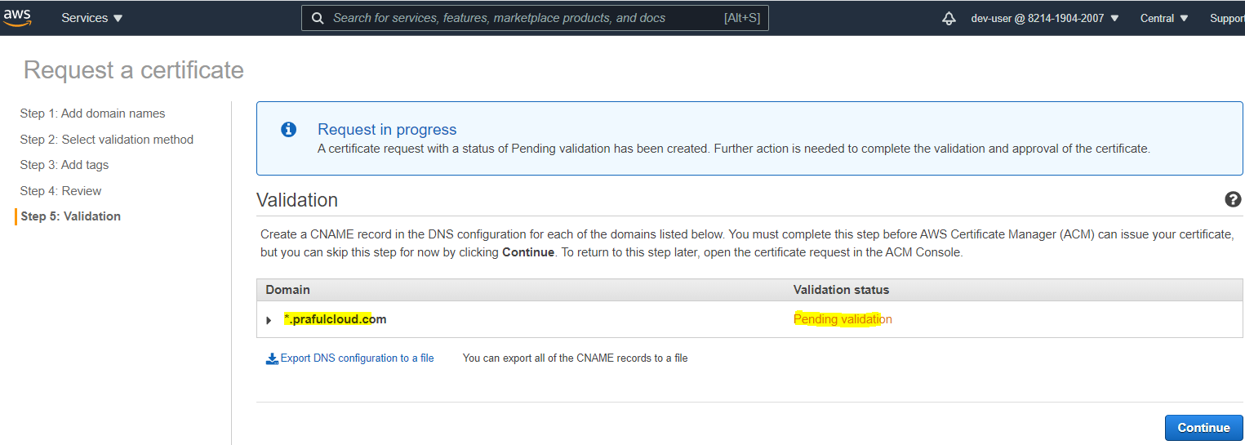

Create record in Route53

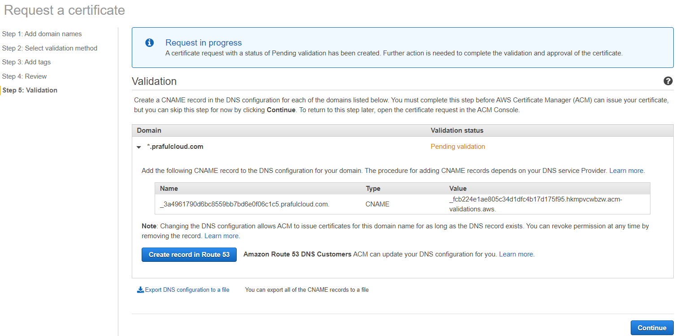

Click to Create

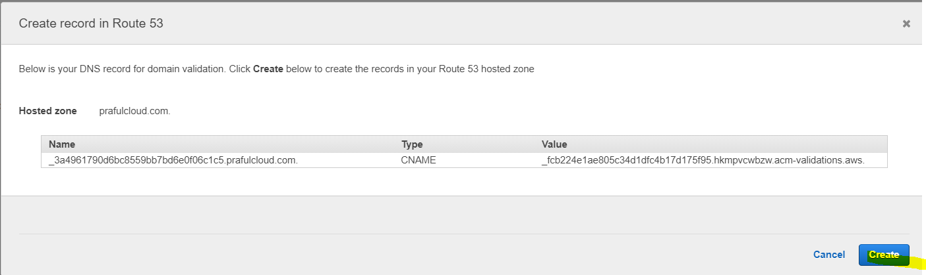

CNAME record added to Route53

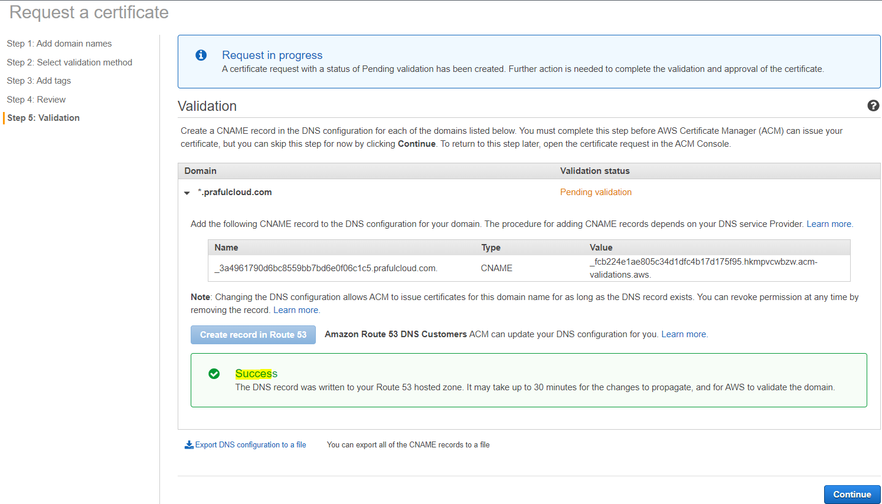

Got to Reoute53 and Verify to Route 53 that record is created

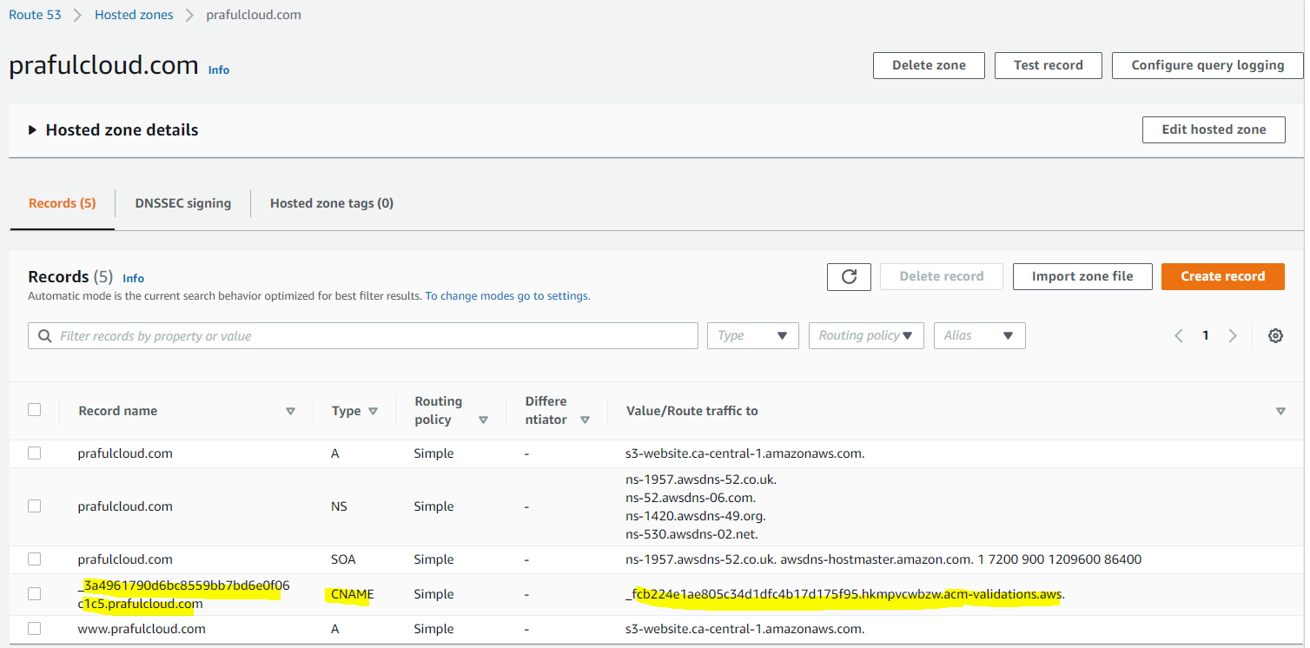

Go to Certificate Manager and finish the process

Click to continue

Validate that certificate is issued.

­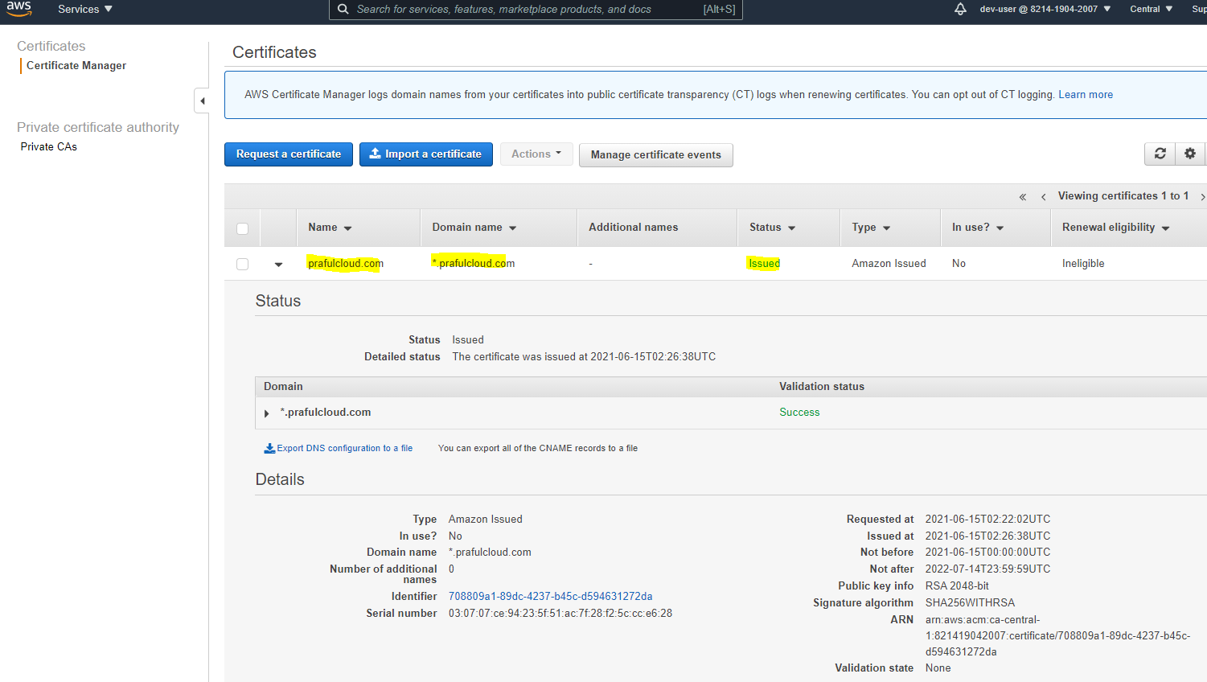

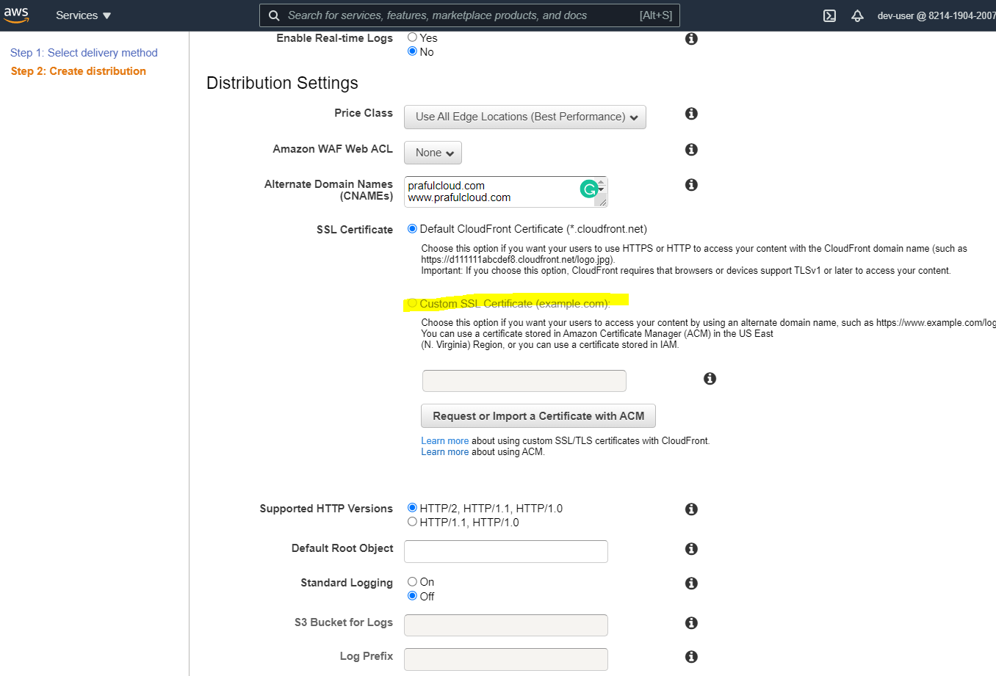

Problem: it has got that the custom SSL certificate option is greyed out, however it has created a new custom certificate.

The current certificate is created in ‘Central’ region which is NOT a valid region to create a certificate, and needs to be selected ‘ N.Virgina’ region in order to be able to create a custom SSL

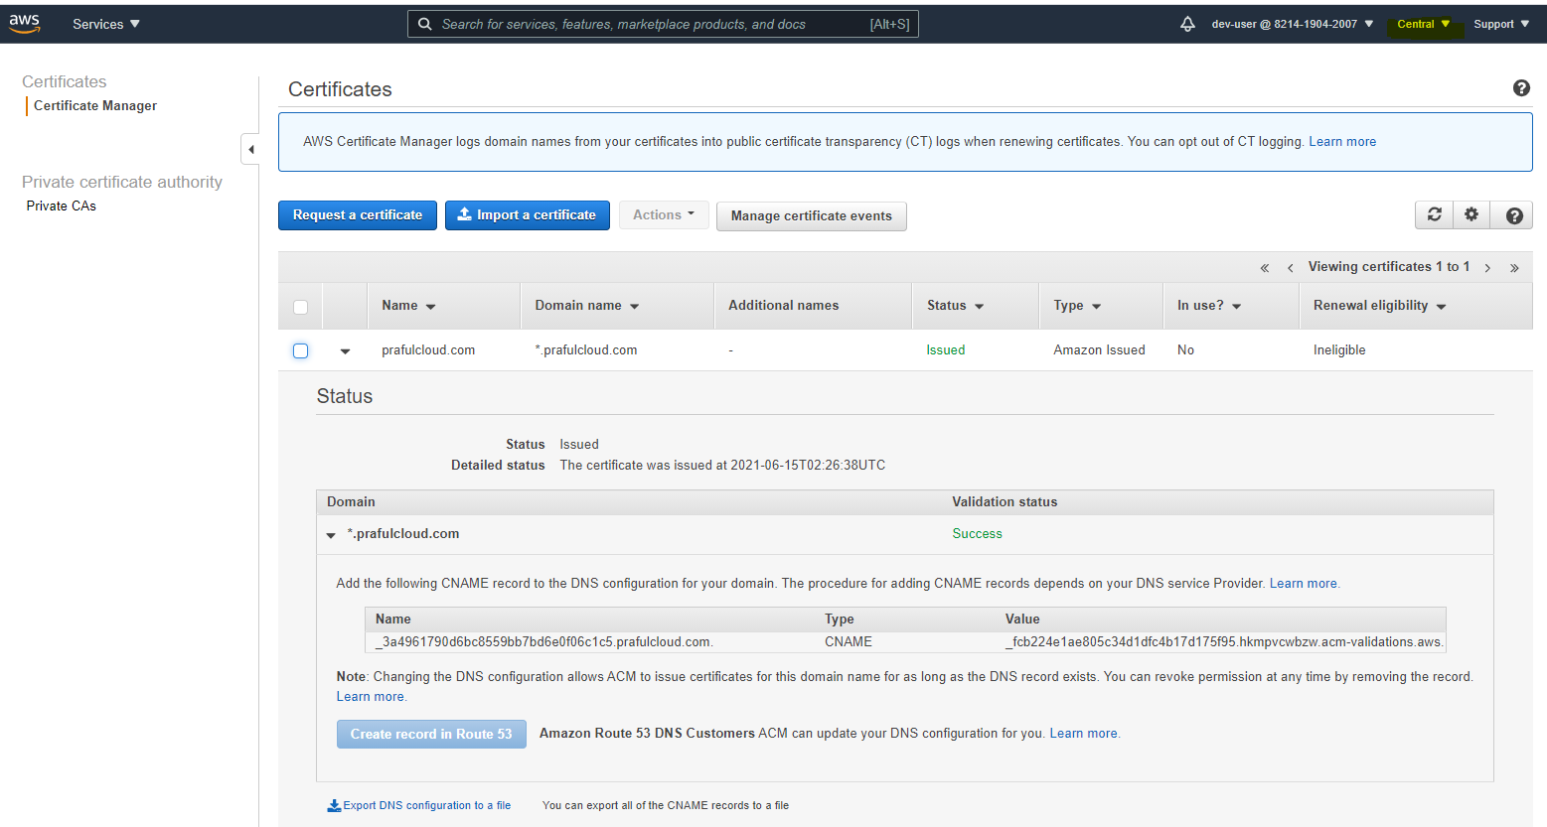

Resolution:

https://aws.amazon.com/premiumsupport/knowledge-center/custom-ssl-certificate-cloudfront/

If you're using a certificate requested from or imported to ACM, confirm that your certificate meets the requirements

* To assign an ACM certificate to a CloudFront distribution, you must request or import the certificate in the [US East (N. Virginia) Region](https://docs.aws.amazon.com/acm/latest/userguide/acm-regions.html). If you're using the [ACM console](https://console.aws.amazon.com/acm/), check the Region selector in the navigation bar. Confirm that US East (N. Virginia) is selected before you request or import the certificate.  
  Note: After you assign an ACM certificate to a CloudFront distribution, the certificate is distributed to all edge locations for the [CloudFront distribution's price class](https://docs.aws.amazon.com/AmazonCloudFront/latest/DeveloperGuide/PriceClass.html" \t "_blank).

Click to Certificate Manager

Select the region: N.Virginia

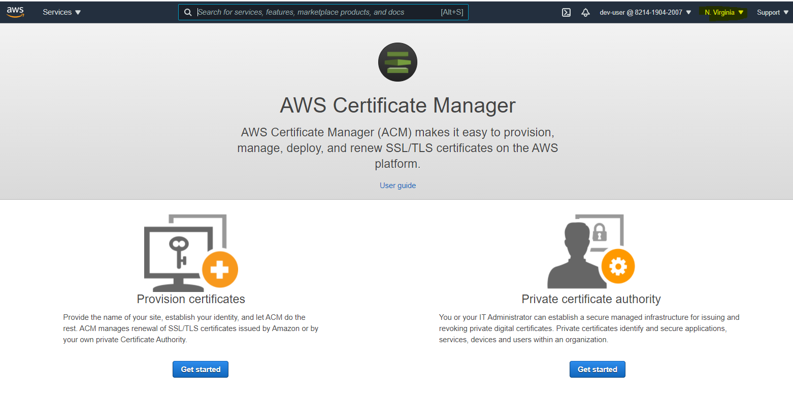

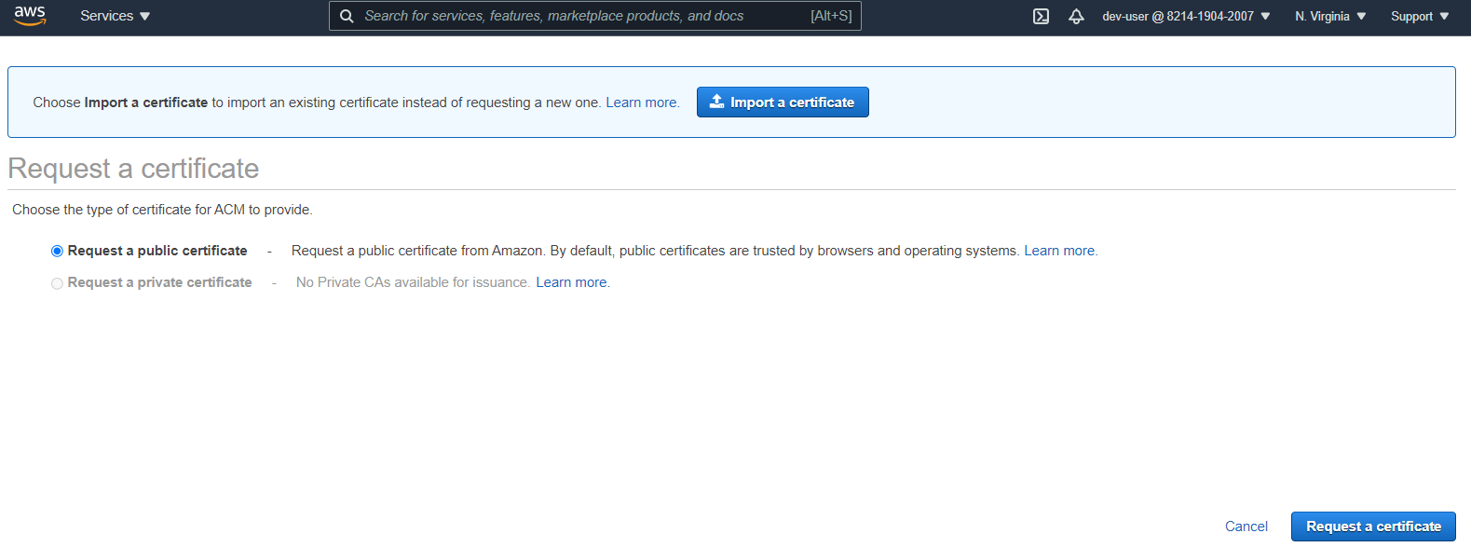

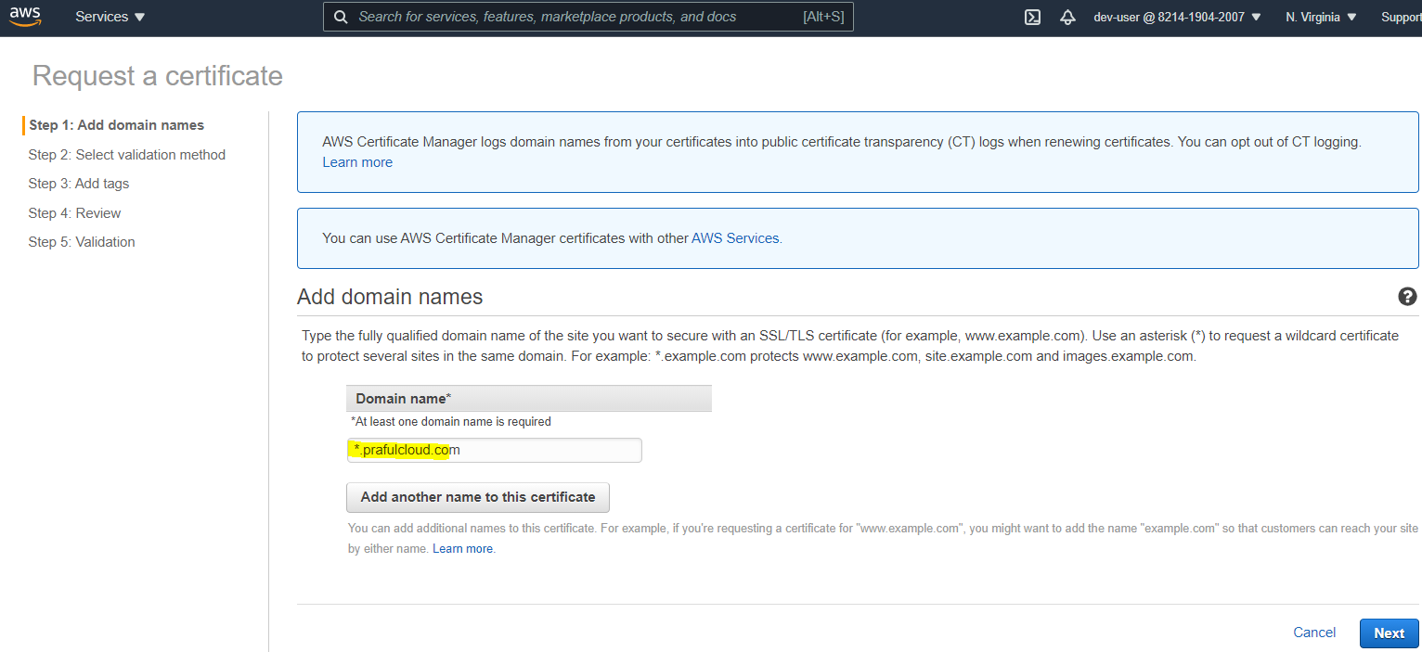

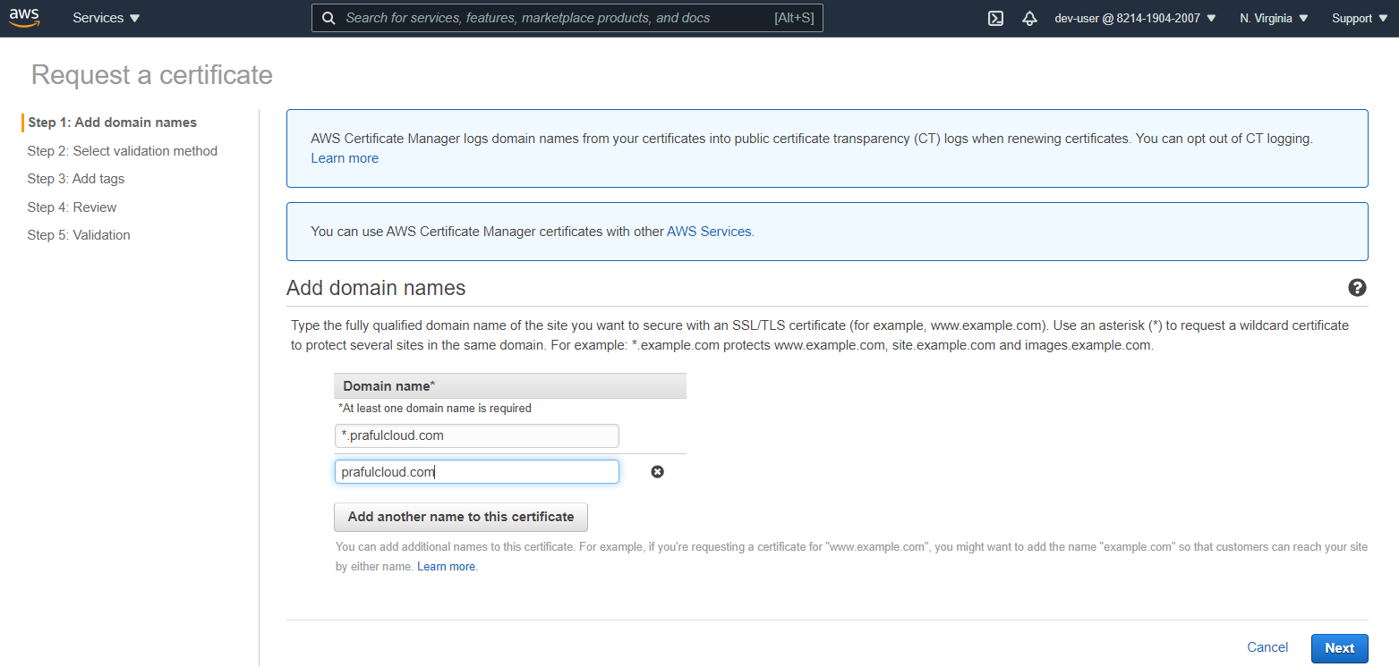

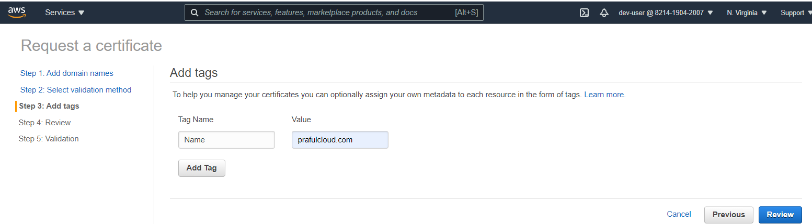

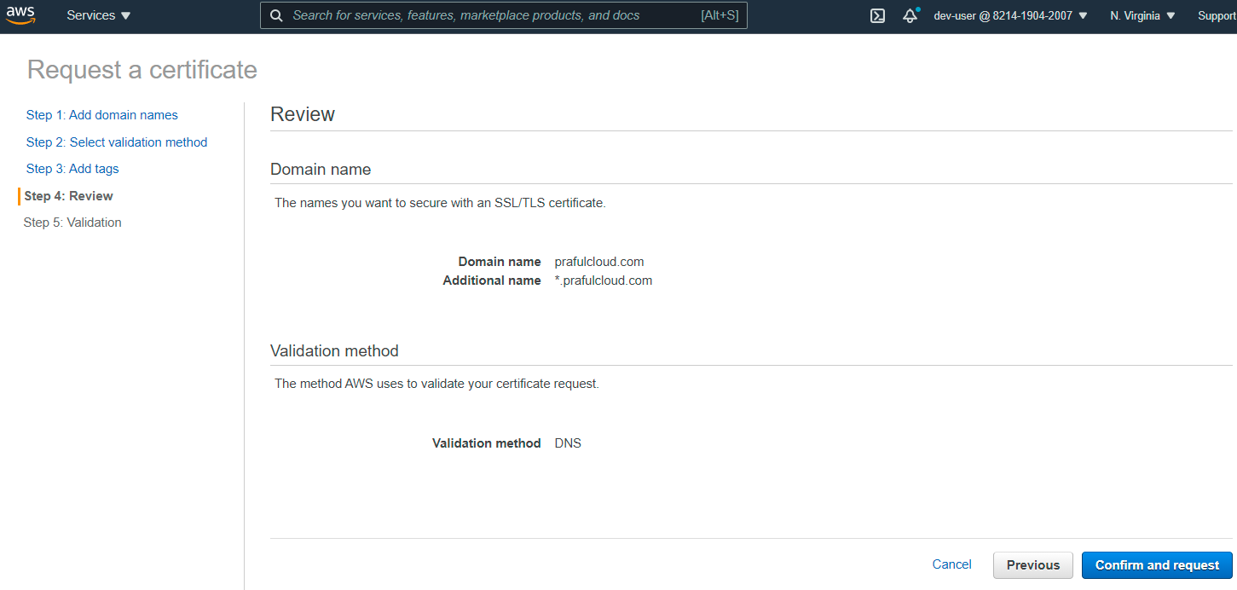

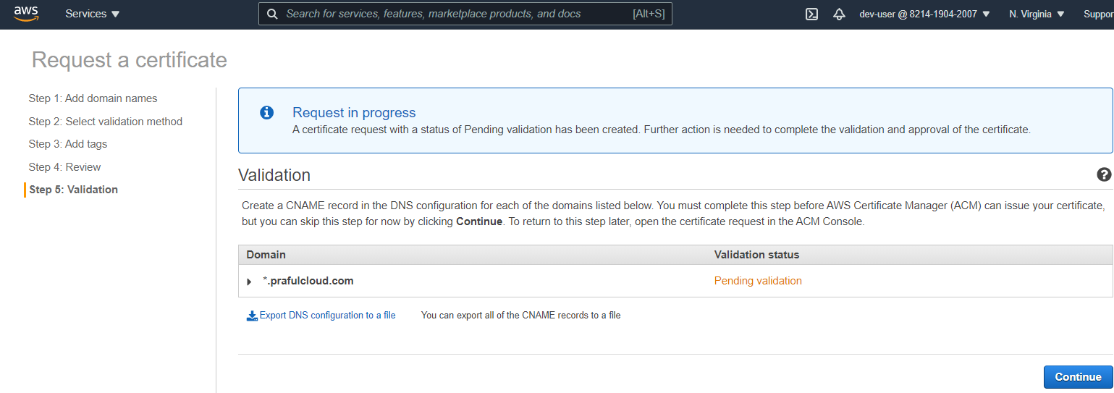

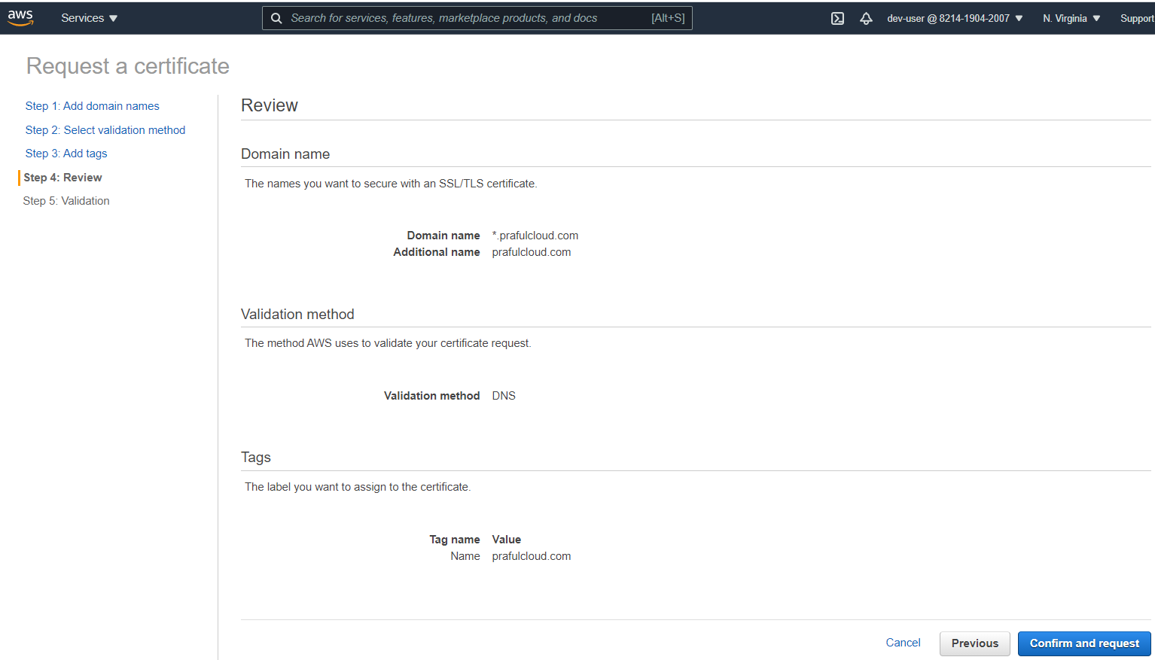

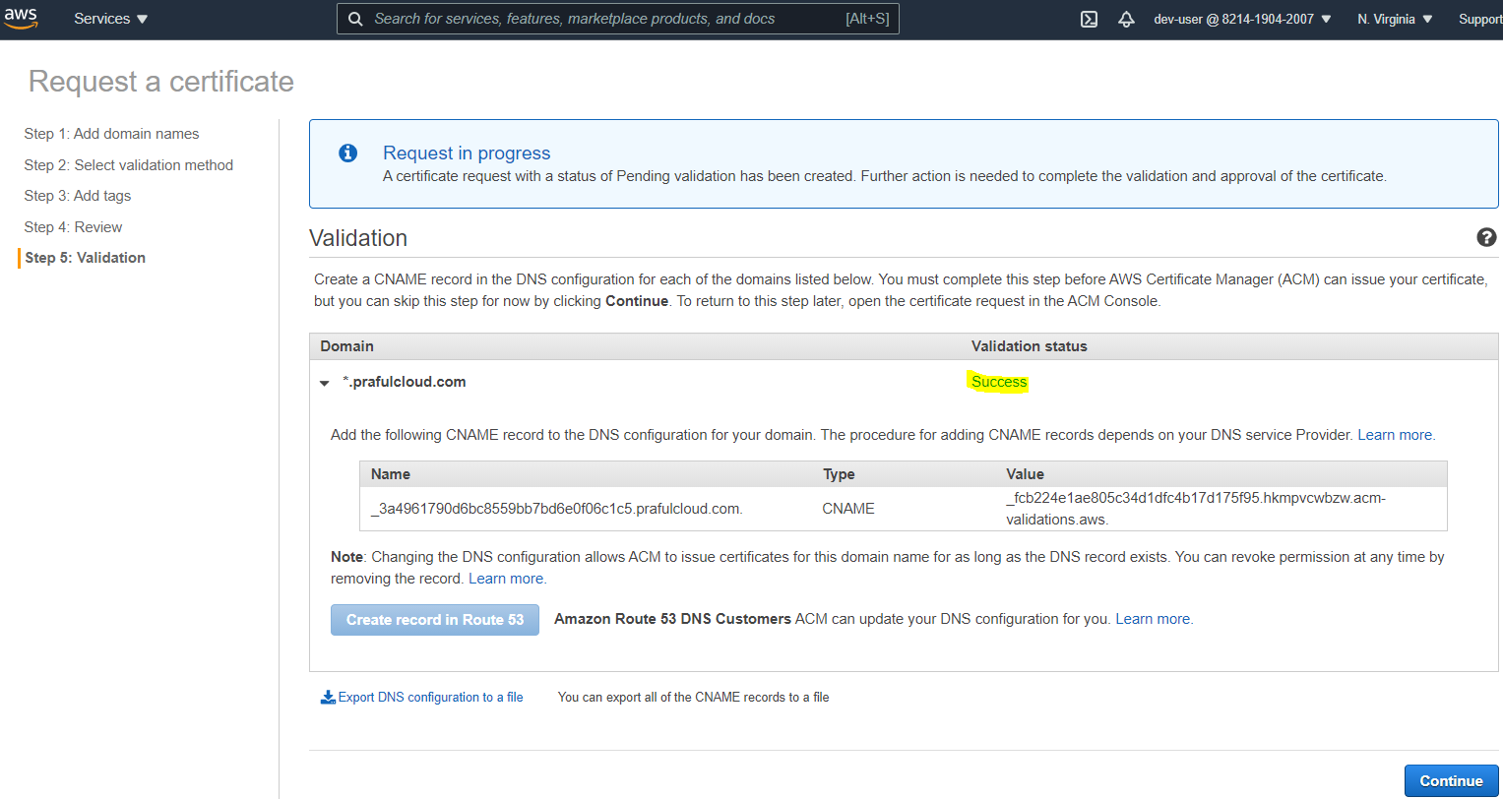

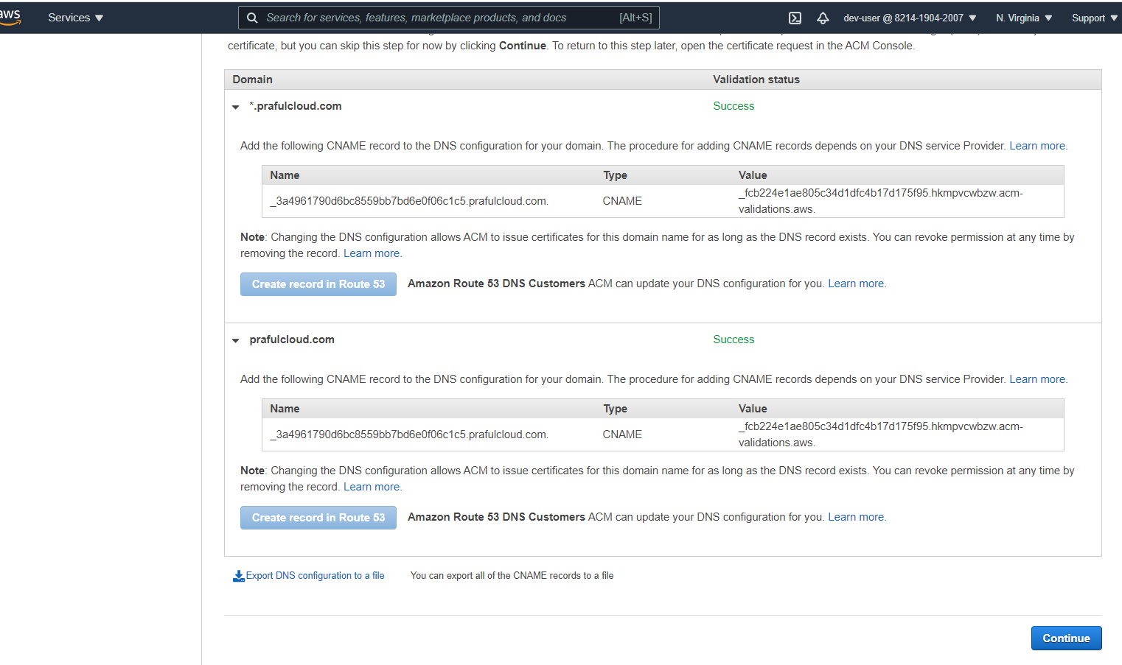

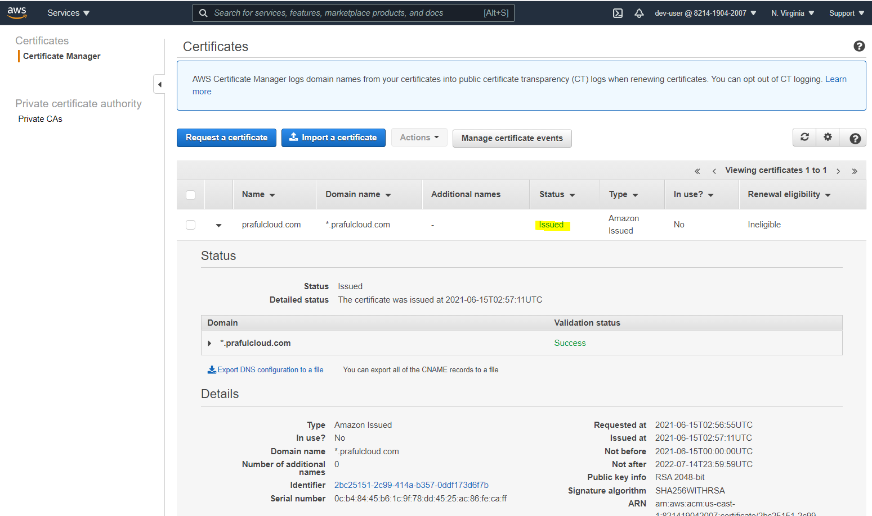

Go back to Cloudfront and select the appropriate options and create cloud front distribution

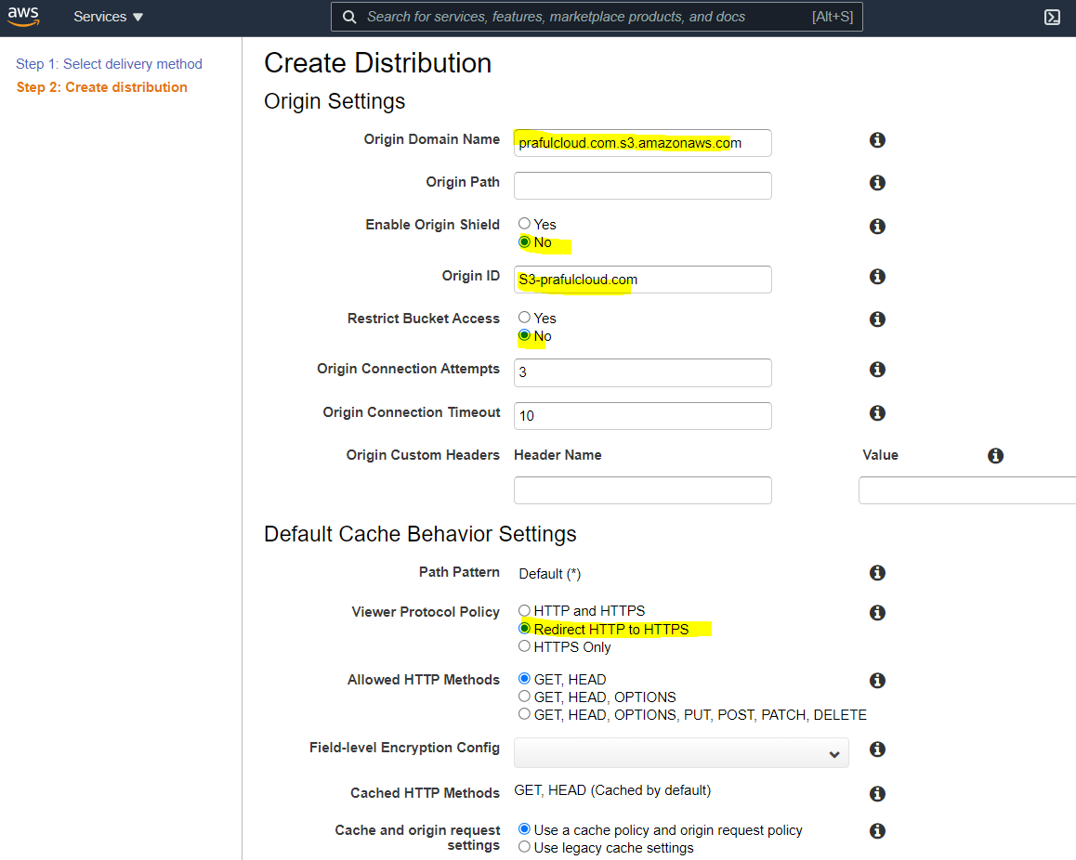

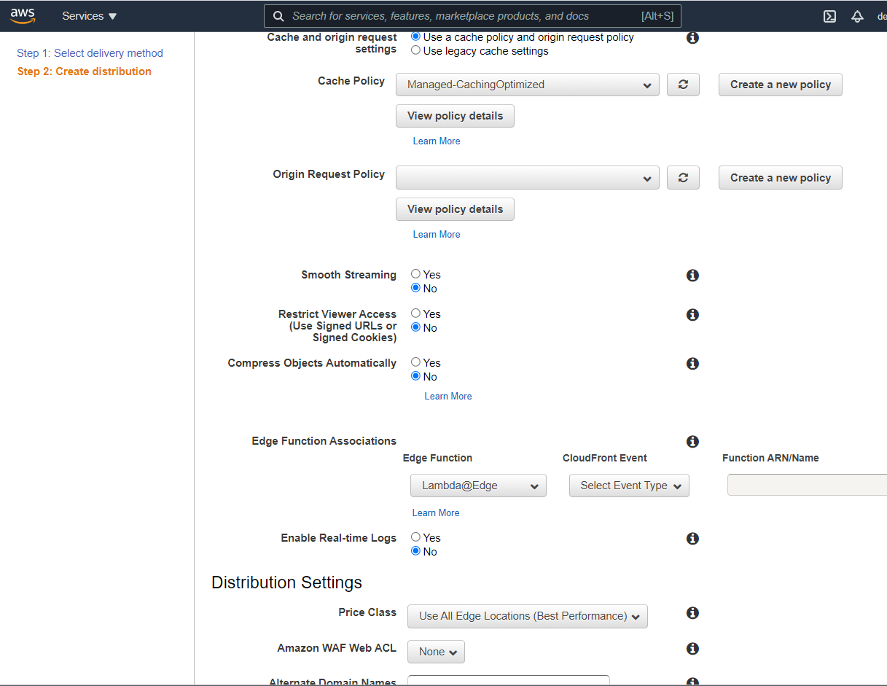

Enter Domain names

Validate that ‘Custom SSL Certificate option is enabled

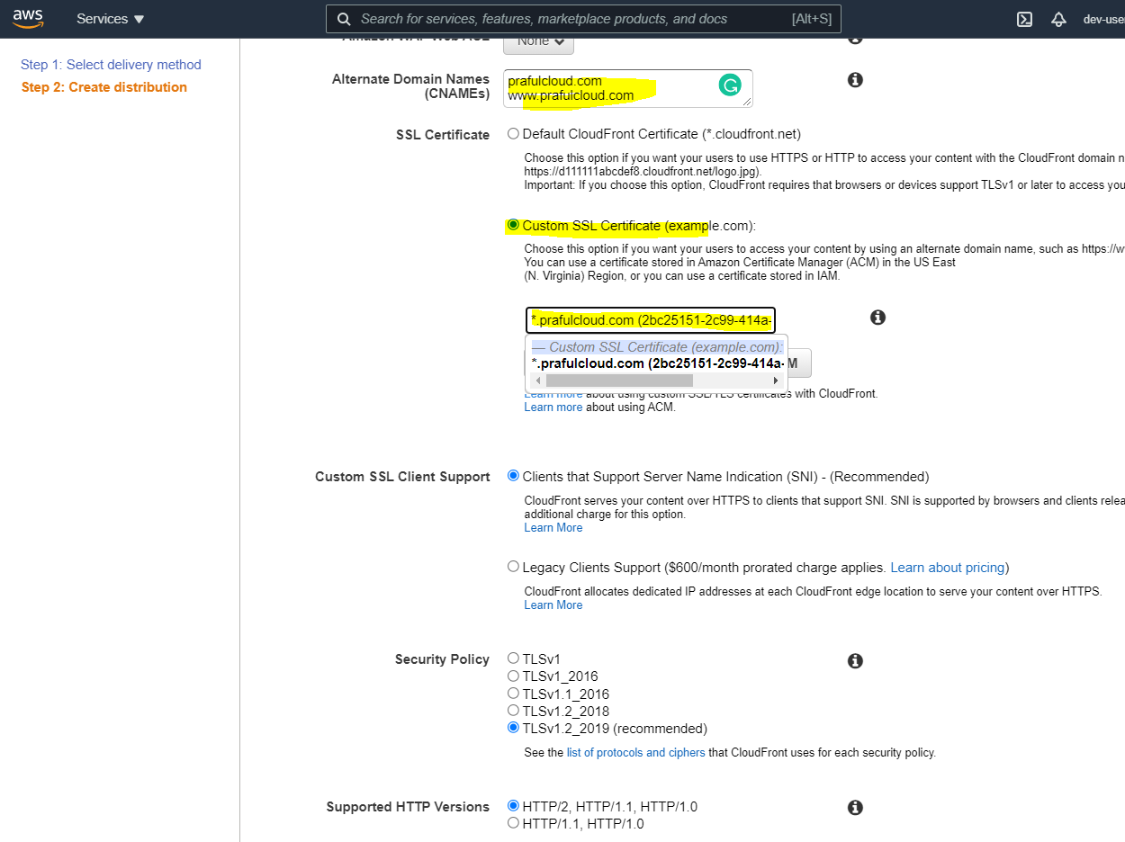

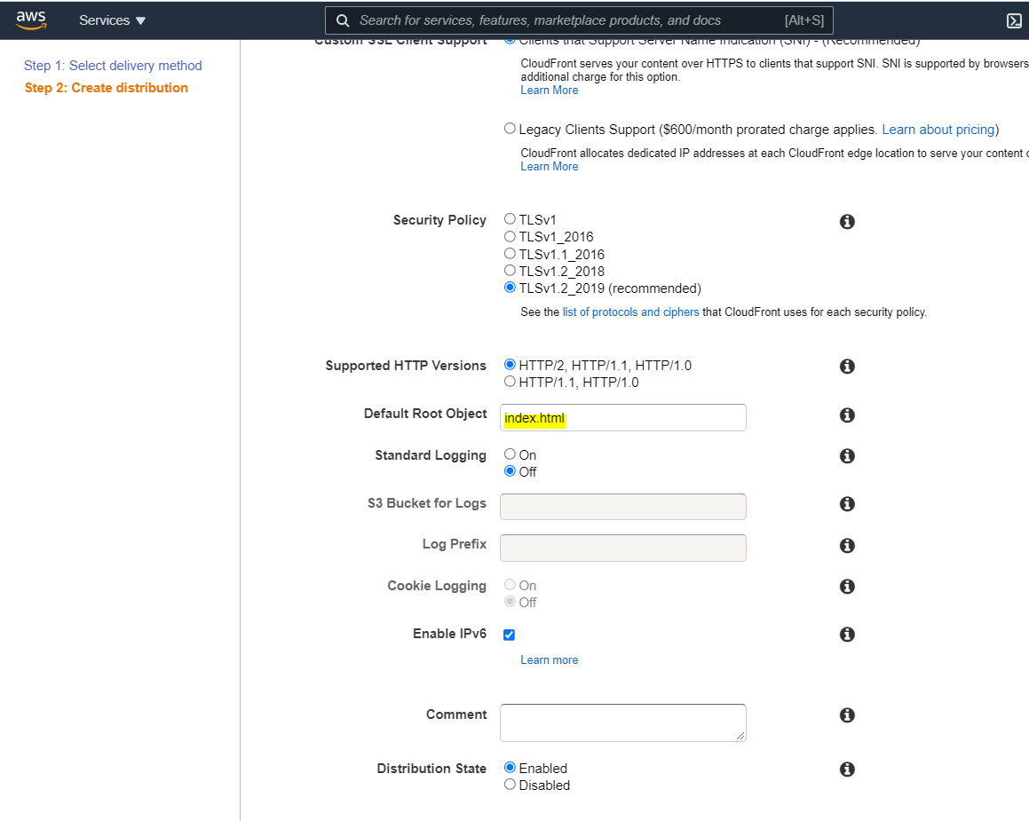

Cloudfront distribution in progress

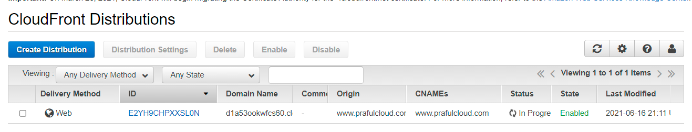

Cloudfront distribution deployed

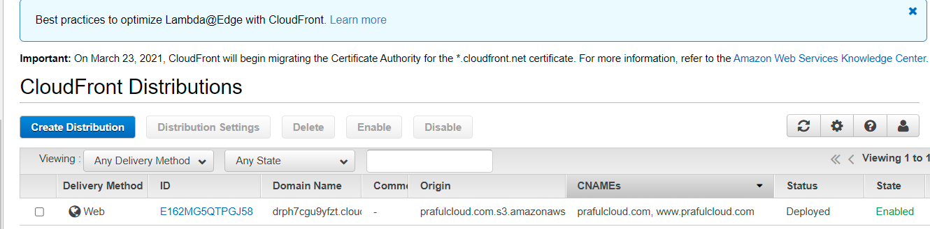

Validate that website is secured using HTTPS

In order to access the custom domain www.prafulcloud.com , it needs to create an alias record in route53 using cloudfront Domain name

**Domain Name**

dbjz461htmg88.cloudfront.net

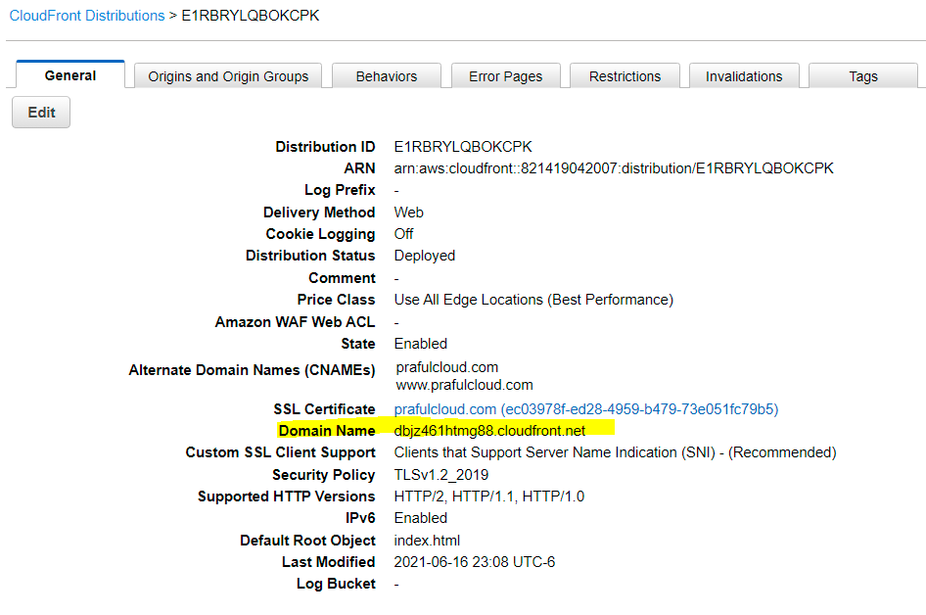

Go to Route53

Create an alias

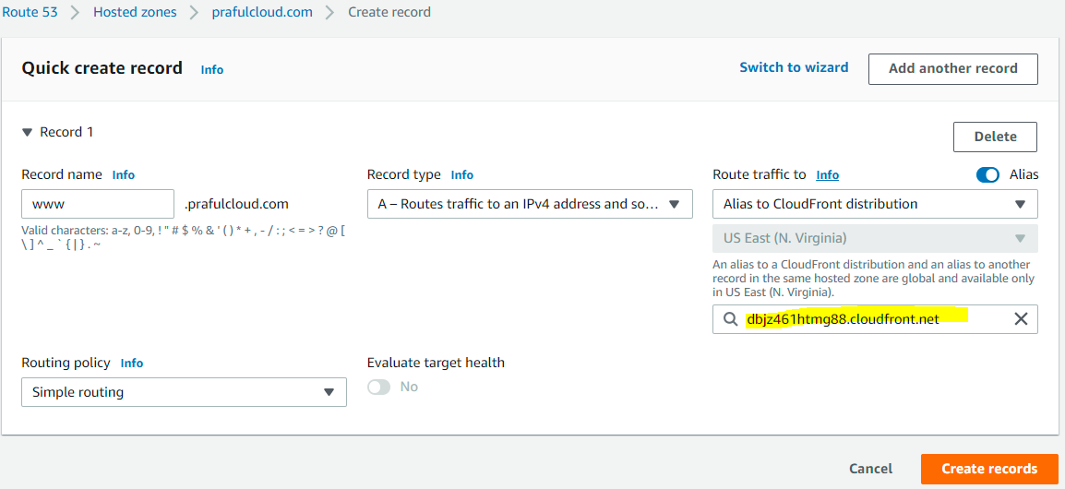

Before applied SSL certificate

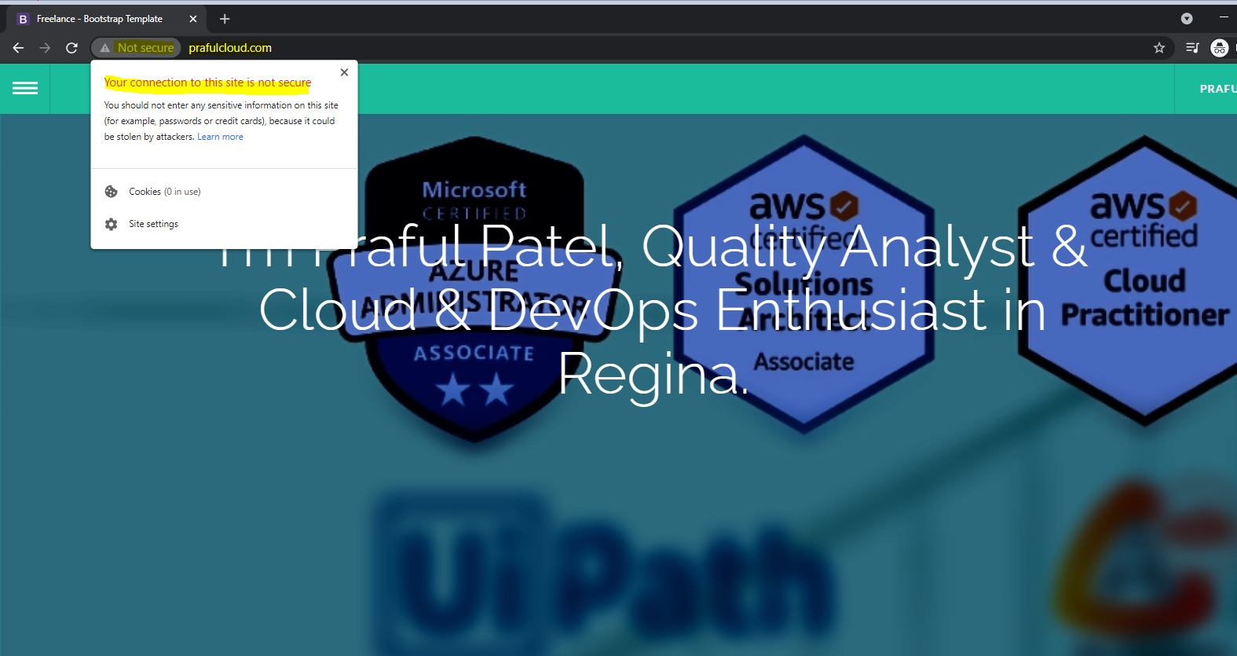

After applied SSL certificate

Validate that website is secured

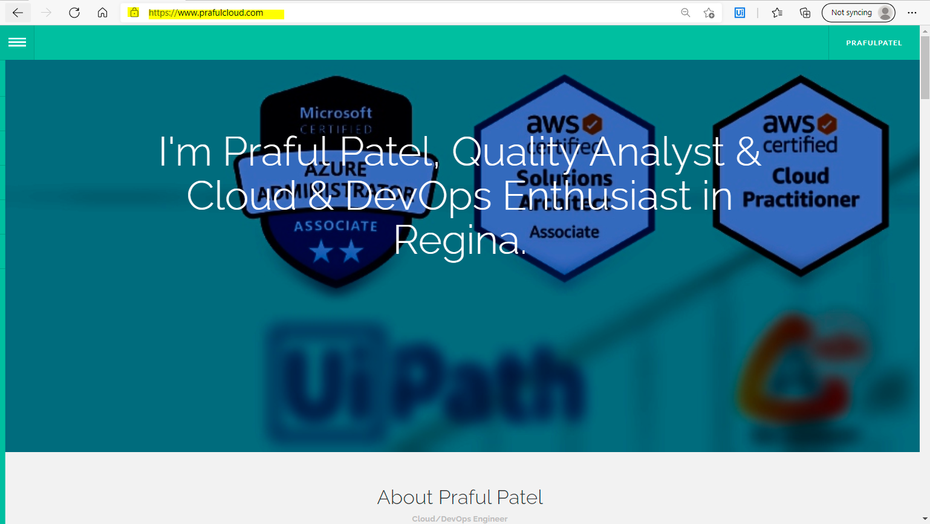

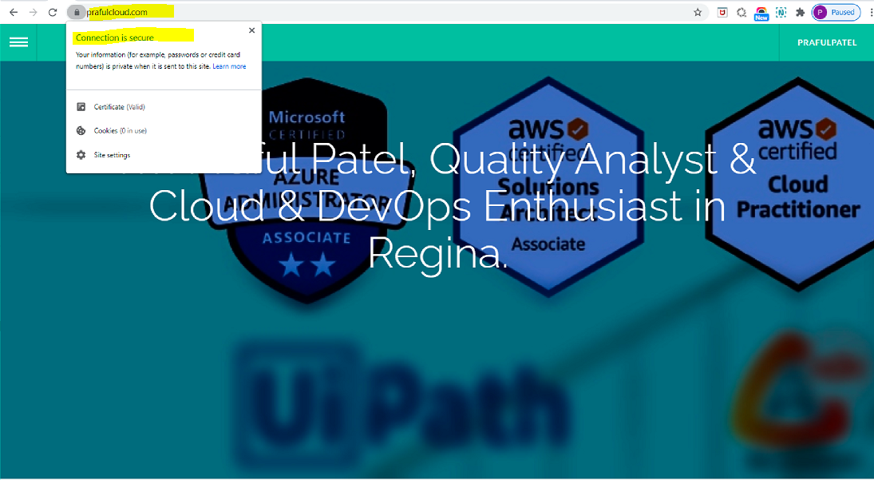

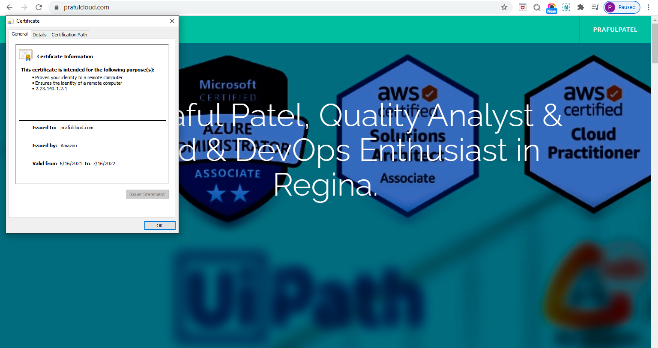

**Configure Invalidation in Cloudfront:**

**Link: https://docs.aws.amazon.com/AmazonCloudFront/latest/DeveloperGuide/Invalidation.html**

If you need to remove a file from CloudFront edge caches before it expires, you can do one of the following:

* Invalidate the file from edge caches. The next time a viewer requests the file, CloudFront returns to the origin to fetch the latest version of the file.
* Use file versioning to serve a different version of the file that has a different name. For more information, see [Updating Existing Files Using Versioned File Names](https://docs.aws.amazon.com/AmazonCloudFront/latest/DeveloperGuide/UpdatingExistingObjects.html#ReplacingObjects).

Validate the solution

Verify the URL: prafulcloud.com

**Problem:**

Validate that the title has been updated and saved the updated file into the bucket but it hasn’t yet effected on the browser through cloudfront. But if you just look at the direct url link from S3 it seems to be updated.

**Solution:**

we need to go to the cloudfront invalidation section and have to update or clear the invalidations to the request will go to the origin rather to fetch the data from the cloudfront cache and it will store the new content in the cache.

S3 bucket url: http://prafulcloud.com.s3-website-us-east-1.amazonaws.com/

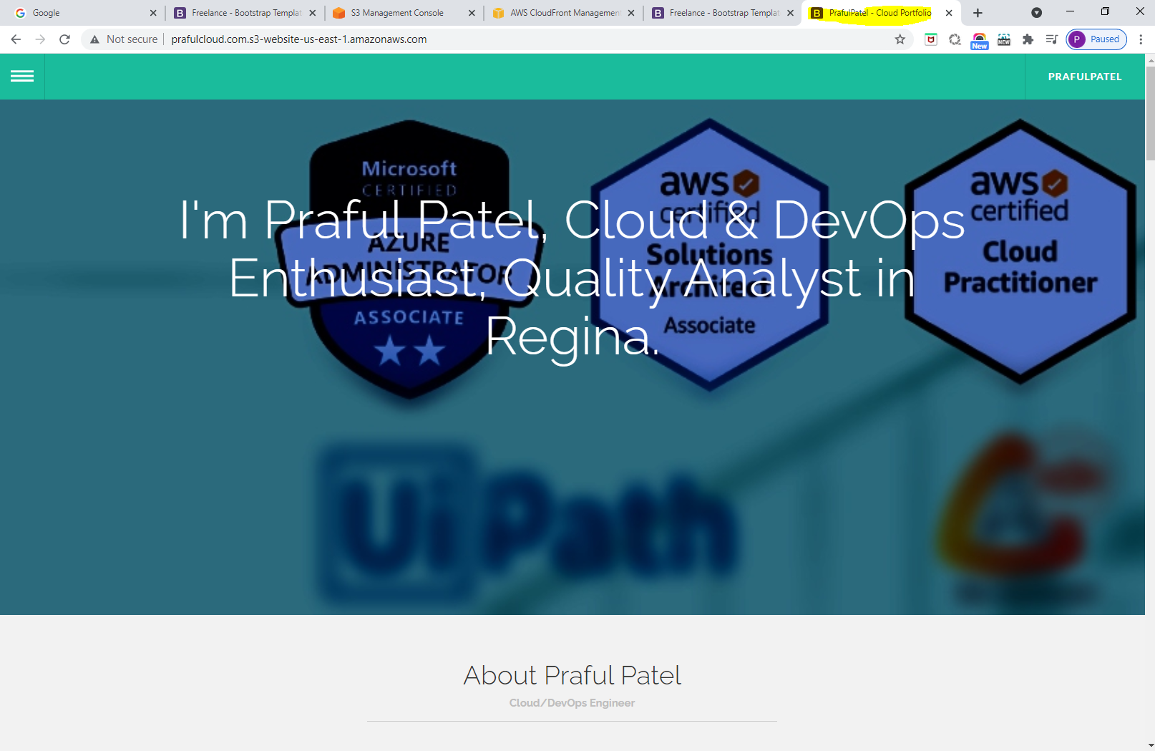

**Invalidation Solution:**

**Click to created disctribution**

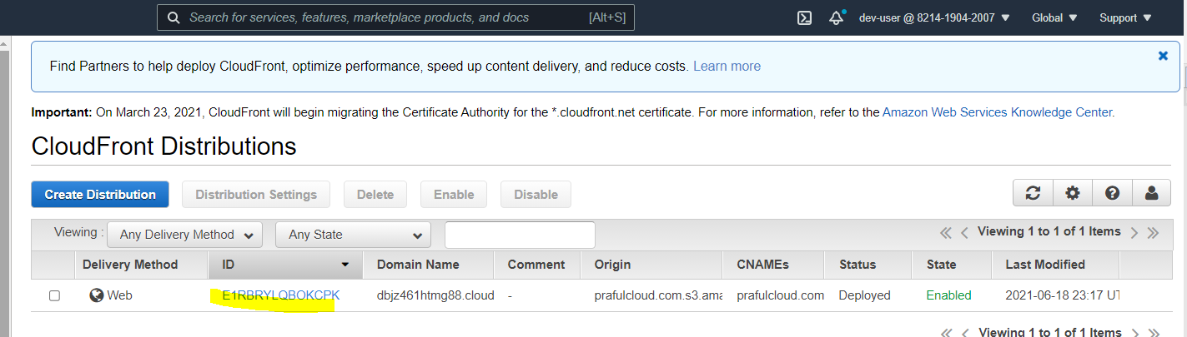

Click on Invalidations

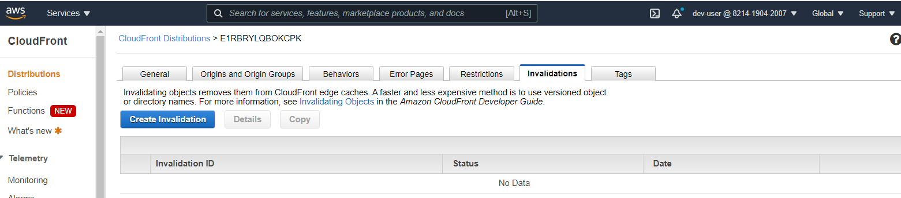

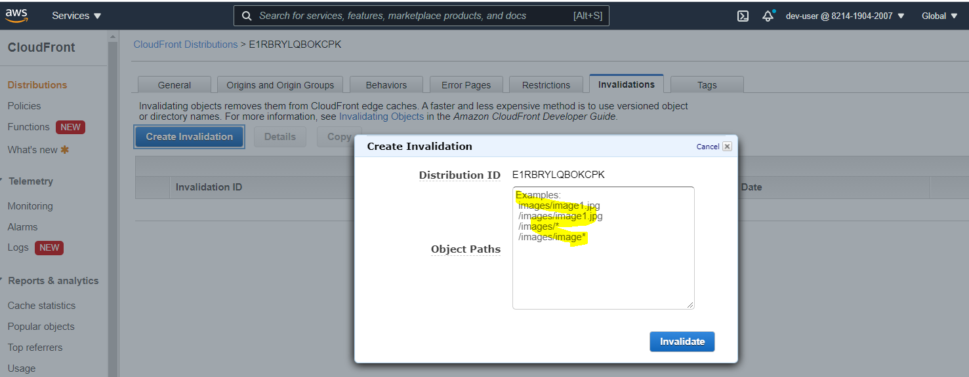

Apply /\* which is applicable to all the content rather than specific

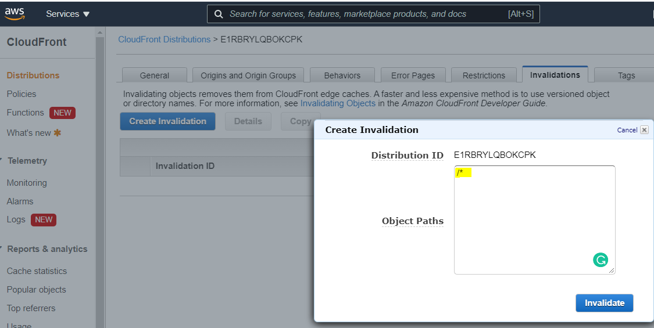

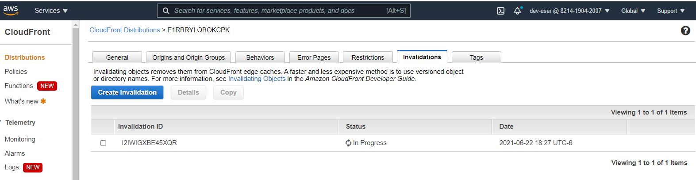

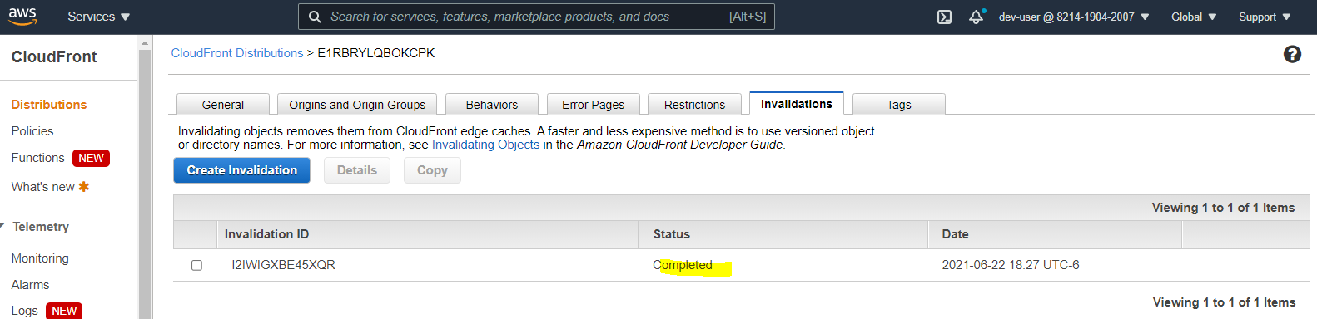

Upon Complete

Validate the URL

Before:

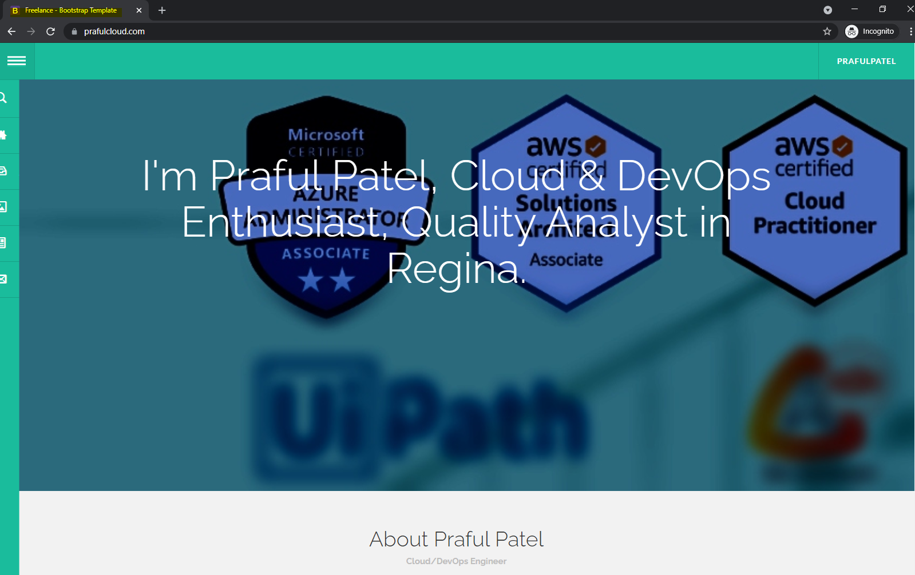

After:

